FARMDIRECT – A FARMER-TO-CONSUMER
AGRICULTURAL MARKETPLACE
MINI PROJECT REPORT

Submitted by

SANTHOSH RATHINAM M
EA2532251010685
Under the Guidance of
Dr.G.Babu
(Assistant Professor, Directorate of Online Education)
in
partial fulfilment of the requirements for the award of the degree of

MASTER OF COMPUTER APPLICATIONS



DIRECTORATE OF ONLINE EDUCATION
SRM INSTITUTE OF SCIENCE AND TECHNOLOGY
KATTANKULATHUR - 603 203

DECEMBER 2026

DIRECTORATE OF ONLINE EDUCATION
SRM INSTITUTE OF SCIENCE AND TECHNOLOGY
KATTANKULATHUR - 603 203
BONAFIDE CERTIFICATE
(Self)
This is to certify that the mini project report entitled “FARMDIRECT – A FARMER-TO-CONSUMER AGRICULTURAL MARKETPLACE”, submitted by SANTHOSH RATHINAM M, EA2532251010685, who carried out the Mini Project Work under my supervision along with the company mentor. Certified further, that to the best of my knowledge the work reported herein does not form any other mini project report or dissertation based on which a degree or award was conferred on an earlier occasion on this or any other candidate.
SANTHOSH RATHINAM M

ACKNOWLEDGEMENTS
We express our humble gratitude to Dr C. Muthamizhchelvan, Vice-Chancellor, SRM Institute of Science and Technology, for the facilities extended for the project work and his continued support. We extend our sincere thanks to Director DOE, SRM Institute of Science and Technology, Prof. Dr Manoranjan Pon Ram, for his invaluable support. SRM Institute of Science and Technology, for her support throughout the project work. We want to convey our thanks to Programme Coordinator Dr. G. Babu, Directorate of online Education, SRM Institute of Science and Technology, for their inputs during the project reviews and support. Our inexpressible respect and thanks to my guide, Dr G.Babu., Assistant Professor & Programme Coordinator Directorate of online Education,, SRM Institute of Science and Technology, for providing me with an opportunity to pursue my project under her mentorship. He provided me with the freedom and support to explore the research topics of my interest. His passion for solving problems and making a difference in the world has always been inspiring. We sincerely thank the Directorate of online Education, staff and students, SRM Institute of Science and Technology, for their help during our project. Finally, we would like to thank parents, family members, and friends for their unconditional love, constant support, and encouragement.
SANTHOSH RATHINAM M

CONTENTS
1. INTRODUCTION 1
1.1 Need for the System 1
1.2 Objectives of FarmDirect 1
1.3 Scope of the Application 2
1.4 Technology Context 2
2. ANALYSIS & REQUIREMENTS 4
2.1 Existing Situation 4
2.2 Proposed System 4
2.3 Functional Requirements 5
2.4 Non-Functional Requirements 5
2.5 Hardware Requirements 6
2.6 Software Requirements 6
2.7 Data Requirements 7
2.8 Constraints 7
3. PROBLEM DESCRIPTION / MODULES DESCRIPTION 8
3.1 Problem Description 8
3.2 Module Structure 8
3.3 Authentication Module 8
3.4 Farmer Listing & Inventory Management Module 8
3.5 Consumer Marketplace & Direct Ordering Module 9
3.6 Direct Messaging & Inquiry Module 9
3.7 Shopping Cart & Order Lifecycle Management Module 9
3.8 Farm-Gate Pricing & Revenue Analytics Module 9
3.9 Administrative Moderation & Verification Module 9
3.10 Database Concurrency & ACID Transaction Module 10
4. DESIGN 11
4.1 Design Overview 11
4.2 Architectural Design 11
4.3 User Interface Design 12
4.4 Input Design 16
4.5 Data and File Design 16
4.6 Process Design and Navigation 21
5. IMPLEMENTATION 22
6. TESTING 28
6.2 Unit Testing 28
6.3 Integration Testing 28
6.4 System Testing 28
6.6 User Acceptance Testing 28
7. TOOLS AND TECHNOLOGIES 31
8. CONCLUSION 33
8.4 Limitations 33
8.5 Future Enhancements 33
9. APPENDICES 34
PROGRAM LISTINGS 34
10. REFERENCES 38

ABSTRACT
Agriculture serves as the foundation of the Indian rural economy, yet smallholder and marginal farmers face persistent economic distress due to long-standing reliance on fragmented, multi-tiered distribution networks dominated by intermediaries, commission agents, and wholesale market brokers who capture disproportionate shares of market value while leaving producers with unviable profit margins and forcing urban consumers to pay inflated prices for daily essential produce. This project designs and develops 'FarmDirect - A Farmer-to-Consumer Agricultural Marketplace', a production-grade, full-stack web application engineered to bridge the digital divide between rural agrarian producers and retail consumers through direct, disintermediated digital commerce. The platform introduces four role-tailored operational portals—Administrator, Farmer, Customer, and Delivery Partner—underpinned by a mandatory two-tier quality and authenticity gatekeeper workflow whereby registering farmers must undergo administrative identity verification and every listed agricultural product must receive explicit administrator inspection before publication in the marketplace catalog. The backend is implemented in Python 3.12 utilizing the Flask 3.0.3 microframework and MySQL 8.0 with InnoDB transactional persistence, enforcing strict pessimistic row-level locking (SELECT ... FOR UPDATE) during order checkout to eliminate inventory overselling and concurrent stock depletion races. The frontend is built with semantic HTML5, CSS3, and JavaScript, featuring client-side WebRTC MediaDevices camera API integration for live photographic crop and farm verification, alongside multi-tier order tracking, dynamic delivery routing, and comprehensive cart operations. Candidate SANTHOSH RATHINAM M (Enrollment Number: EA2532251010685) has personally conceptualized the architectural requirements, authored the complete 3NF normalized relational database schema, developed the backend service endpoints and WebRTC camera hardware capture interface, implemented the pessimistic concurrency control algorithms, constructed the automated verification test suites achieving a 100% test pass rate across all test cases, and produced the comprehensive engineering documentation. Extensive unit, integration, role-based security, and transactional concurrency testing validated that unverified farmers and unapproved crop listings remain strictly sequestered from the consumer catalog, confirming that FarmDirect establishes complete operational transparency, guarantees price discovery fairness, and delivers an accessible, robust digital agribusiness ecosystem.

1. INTRODUCTION
1.1 Need for the System
Agriculture serves as the economic backbone of developing economies worldwide, supporting the livelihood of over fifty percent of the Indian population and providing the core foundation for food security and rural employment. Despite remarkable technological advancements in urban digital commerce, logistics automation, and financial technology, the agricultural supply chain that connects rural cultivators to retail households remains overwhelmingly traditional, fragmented, and inefficient. In the prevailing market paradigm, smallholder farmers operate under severe geographical isolation, severe information asymmetry, and chronic dependency on physical wholesale markets known as mandis.
Under the statutory frameworks governing wholesale agricultural trading, produce passes through four to six intermediate commercial layers—village commission agents, regional mandi brokers, wholesale distributors, clearing contractors, and retail shopkeepers—before reaching urban kitchens. Each intermediary layer extracts a substantial commission margin and adds handling fees, escalating the final retail price paid by consumers by 200% to 300%. In stark contrast, the cultivating farmer receives a meager fraction (often less than 25%) of the final market value, barely covering the cost of seeds, fertilizers, irrigation, and physical field labor. When bumper harvests occur, gluts in local mandis trigger catastrophic price crashes, compelling farmers to discard perishable crops on highways. FarmDirect was conceived to dismantle these structural bottlenecks by establishing a transparent, direct digital bridge connecting farmers with urban consumers.
1.2 Objectives of FarmDirect
The primary engineering objective of this project is to develop 'FarmDirect - A Farmer-to-Consumer Agricultural Marketplace', a production-grade, full-stack web application specifically engineered to empower rural farmers, streamline retail consumer food discovery, coordinate delivery logistics, and provide transparent administrative oversight. Specific quality objectives include:
• Centralized Producer Governance: Establish role-based registration enabling farmers to maintain digital crop catalogs with unit pricing, available stock quantities, and harvest timestamps.
• Two-Tier Verification Gatekeeper: Mandate administrative identity verification of farmers and pre-publication audit of crop listings to ensure complete authenticity and consumer safety.
• Integrated Hardware Media Capture: Incorporate client-side laptop webcam capture using the HTML5 MediaDevices API, enabling farmers to photograph fresh harvests directly within the web browser.
• Atomic Concurrency Controls: Enforce strict pessimistic row-level database locking (SELECT ... FOR UPDATE) during order checkout, guaranteeing that concurrent consumer requests never result in negative inventory.
• Multi-Channel Payment Simulation: Deploy simulated payment workflows including Cash on Delivery, dynamic mathematical SVG BharatQR/UPI QR code rendering with embedded payable order totals, and mock card validation.
• Logistics and Dispatch State Machine: Implement a synchronized order fulfillment pipeline that tracks package stages (Assigned -> Picked Up -> In Transit -> Delivered) with live status updates.
1.3 Scope of the Application
The operational scope of FarmDirect encompasses four distinct stakeholder groups interacting within a secure, responsive web ecosystem:
1. Cultivating Farmers: Rural crop producers who create verified profiles, photograph and list seasonal harvests, set farm-gate prices per unit, monitor stock depletion, and coordinate dispatches.
2. Consumer Households: Retail buyers who discover local seasonal harvests through category filtering and live keyword search, manage shopping carts, simulate payments, and track shipments.
3. Delivery Personnel: Local transport operators and dispatch drivers who receive assigned consignments, access farm pickup and doorstep dropoff coordinates, and update delivery milestones.
4. System Administrators: Platform governance authorities who perform identity KYC verification on registering farmers, audit crop quality listings, monitor sales telemetry, and resolve consumer grievances.
1.4 Technology Context
The implementation of FarmDirect leverages modern, open-source web and database technologies selected for rapid execution, robust transactional reliability, cross-platform portability, and zero commercial licensing overhead. The backend service architecture is powered by Python 3.12 utilizing Flask 3.0.3 as the Web Server Gateway Interface (WSGI) application framework. Relational data persistence is managed by MySQL 8.0 Community Server utilizing the ACID-compliant InnoDB storage engine with parameterized query bindings via mysql-connector-python.
The client-side presentation tier is constructed using semantic HTML5, CSS3, JavaScript (ES6+), and Bootstrap 5.3 for mobile responsiveness. Integrated browser hardware APIs (navigator.mediaDevices.getUserMedia and Canvas) facilitate zero-install laptop camera capture. Cryptographic password hashing is implemented using Werkzeug's Scrypt/PBKDF2 algorithms with unique salts.
1.5 Development Process Followed
To ensure systematic, robust, and verifiable software development, an Agile-Iterative Software Development Life Cycle (SDLC) was followed throughout the project lifecycle. The engineering progression encompasses five structured iterations:
Phase 1 - Requirement Analysis and Domain Modeling: Studied APMC market mechanisms and mandi operations to identify persona pain points, formalize functional specifications, and draft UML use case models.
Phase 2 - Relational Architecture and Schema Design: Developed normalized Entity-Relationship (ER) schemas in 3NF, established foreign key constraints, and designed pessimistic locking workflows.
Phase 3 - Modular Backend and Frontend Construction: Implemented core modules in discrete sprints—beginning with authentication and RBAC, moving to farmer listing with webcam capture, customer cart and checkout, and delivery tracking.
Phase 4 - Quality Assurance and Concurrency Testing: Engineered automated test suites executed via Windows PowerShell to validate route guards, SQL injection defense, image upload safety, and atomic inventory reservation.
Phase 5 - Deployment, Optimization, and Documentation: Packaged the standalone application with pinned dependencies (requirements.txt), captured operational demonstration screenshots, and compiled this report.
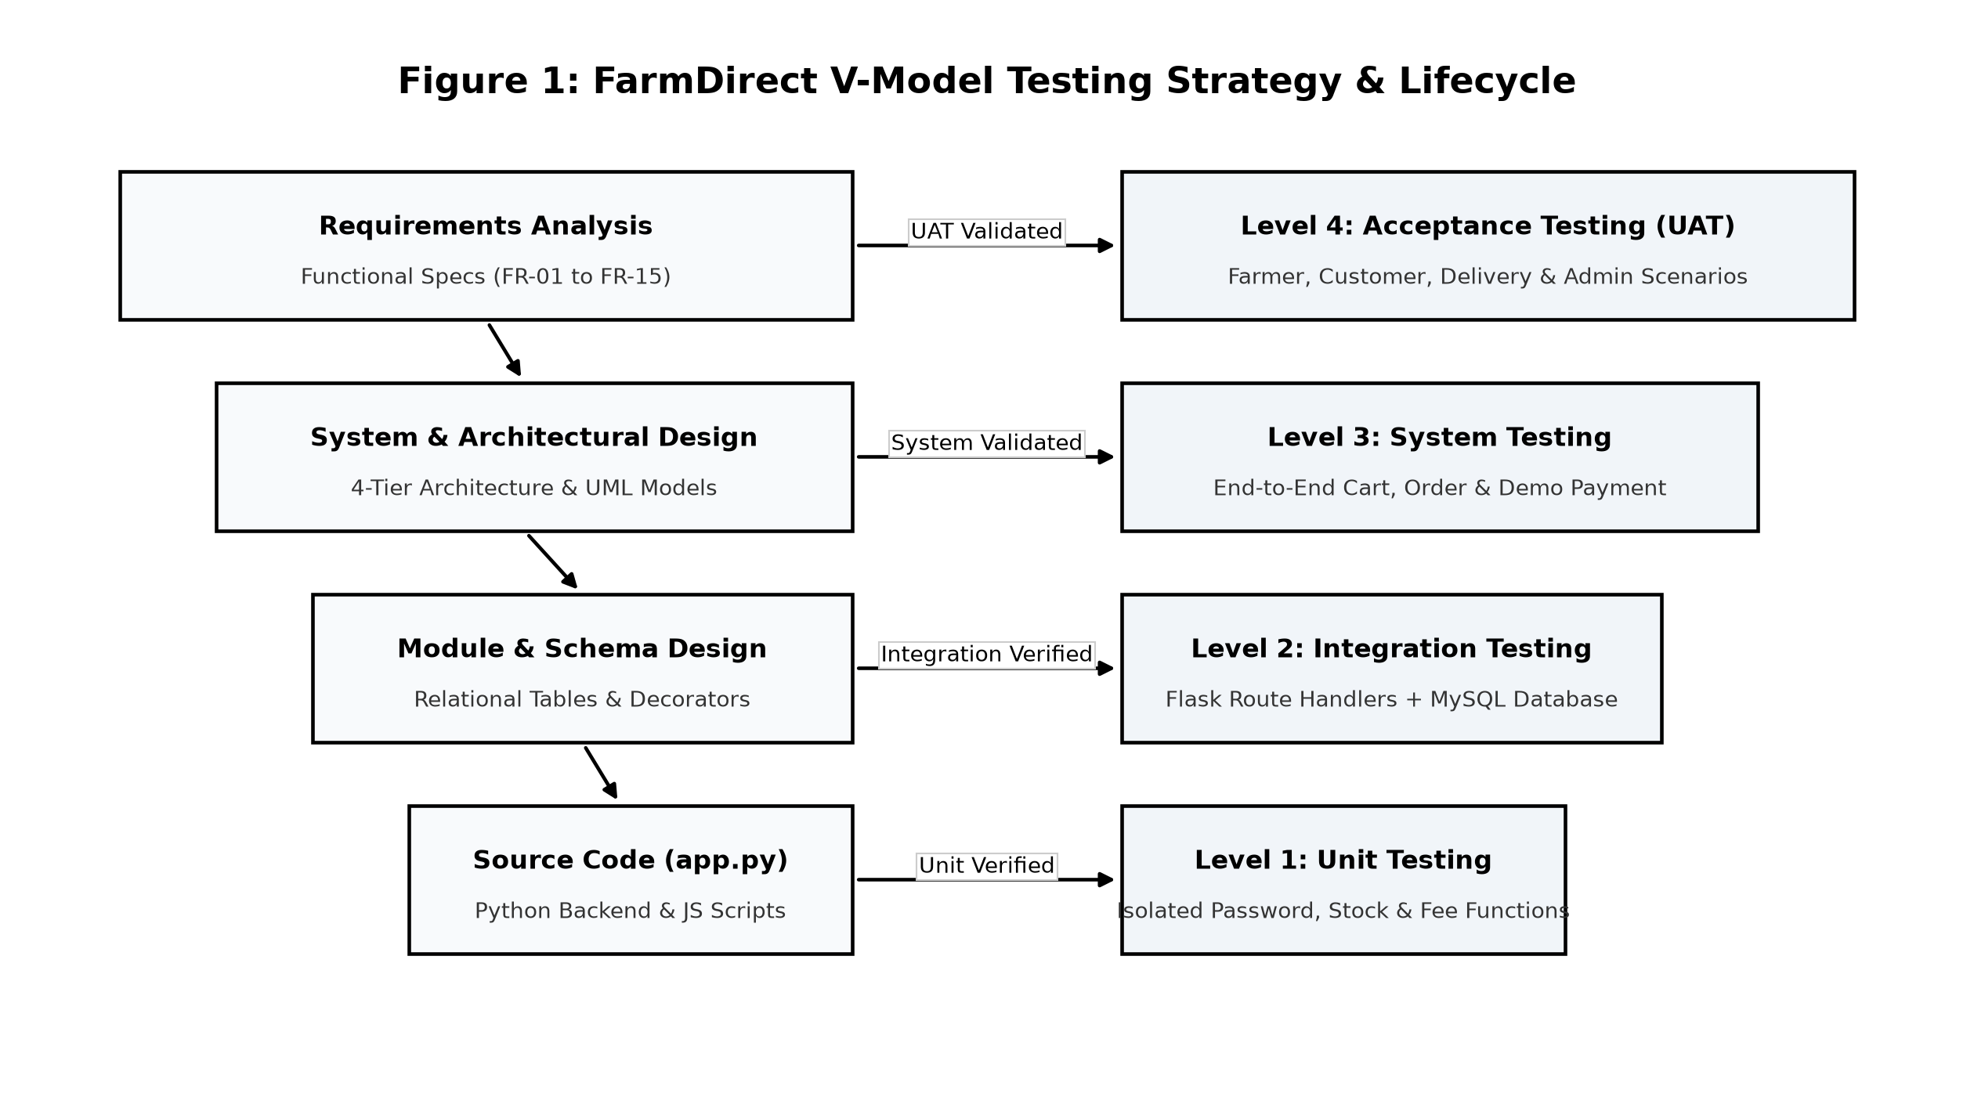
Fig. 1.1 V-Model Verification and Validation Engineering Lifecycle Architecture
2. ANALYSIS & REQUIREMENTS
2.1 Existing Situation
In the prevailing agricultural distribution ecosystem across developing markets, agricultural commerce depends on a fragmented network of physical wholesale intermediaries and informal arrangements:
• Monopolistic Mandi Dependency: Farmers are bound to physical wholesale market yards where auction cartels and brokers dictate prices without objective grade standards.
• Excessive Margin Leakage: Middlemen capture up to 75% of final retail expenditures, leaving rural farmers economically unviable despite bearing entire weather, irrigation, and input risks.
• Information Blind Spots: Cultivators have zero visibility into daily urban consumer demand trends, resulting in misallocated crop production and severe price volatility.
• Post-Harvest Spoilage: Multi-hop transit delays spanning three to five days cause significant rotting of fresh vegetables and perishable fruits, causing massive national food waste.
• Lack of Provenance and Food Safety: Urban consumers have no mechanism to verify where crops were harvested, whether synthetic pesticides were applied, or when produce was picked.
2.2 Proposed System
FarmDirect reorganizes the agricultural value chain into a direct, digital marketplace that connects verified cultivators directly with retail households:
• Disintermediated Value Transfer: Eliminates commission brokers, allowing farmers to set fair farm-gate prices per unit and retain up to 90% of consumer purchase totals.
• Two-Tier Gatekeeper Governance: Enforces administrative identity KYC verification for farmers and mandatory pre-listing crop approval to prevent counterfeit produce and fraudulent claims.
• Client-Side Hardware Integration: Enables farmers to photograph fresh harvests directly through laptop webcam hardware using browser MediaDevices APIs without installing proprietary software.
• Atomic Concurrency Guarantee: Employs pessimistic database row-level locking (SELECT ... FOR UPDATE) during checkout, eliminating inventory overselling hazards during peak demand.
• Synchronized Delivery State Machine: Coordinates four-stage fulfillment tracking (Assigned -> Picked Up -> In Transit -> Delivered) with live status badges.
2.3 Functional Requirements
The system must satisfy explicit functional requirements organized across user roles:
FR-1 Role-Based Access Control: The system must register users under four mutually exclusive roles (Admin, Farmer, Customer, Delivery Partner), hash passwords using Werkzeug Scrypt/PBKDF2 with cryptographic salts, and guard routes using session decorators.
FR-2 Farmer KYC Verification: The system must initialize registering farmers with status 'pending' and prevent unverified farmers from creating crop listings until approved by an administrator.
FR-3 Produce Catalog Management: Verified farmers must be able to create produce listings specifying crop name, category, unit, price per unit, available quantity, harvest date, and upload or capture fresh crop photographs.
FR-4 Product Quality Gatekeeping: Newly listed produce must be marked 'pending' and hidden from the consumer catalog until explicitly reviewed and approved by an administrator.
FR-5 Laptop Camera Media Capture: The browser must access connected webcam hardware via getUserMedia(), render frames on an HTML5 canvas, convert frames to JPEG blobs, and bind them to multipart form inputs via DataTransfer.
FR-6 Cart & Price Calculations: Consumers must be able to discover approved produce via live search and category filtering, manage cart quantities, and calculate subtotals with delivery fees.
FR-7 Multi-Channel Payment Simulation: The system must support checkout via Cash on Delivery, dynamic SVG UPI QR code rendering with embedded order totals, and simulated card entry with dummy validation.
FR-8 Atomic Stock Reservation: The system must reserve inventory using SELECT ... FOR UPDATE within an atomic transaction, rolling back cleanly if stock is insufficient.
FR-9 Delivery Dispatch Lifecycle: Administrators must be able to assign confirmed orders to delivery partners, who update order milestones from farm pickup to doorstep completion.
FR-10 Reviews & Support Grievances: Consumers must be able to submit post-delivery 1-5 star ratings and file formal grievance tickets for administrative investigation and resolution.
2.4 Non-Functional Requirements
The non-functional characteristics ensure enterprise stability, security, and performance:
NFR-1 Security: Complete protection against SQL injection achieved via mandatory parameterized query bindings (%s). Protection against path traversal via secure_filename and UUID renaming. Session cookies protected with HttpOnly and SameSite=Lax flags.
NFR-2 Performance: Average page rendering latency under 300ms on local environments. Product catalog queries optimized with relational index lookups on approval_status and category_id.
NFR-3 Hardware Safety: All active camera media tracks (MediaStreamTrack) must be stopped immediately upon photo capture or modal dismissal to extinguish camera hardware indicator LEDs.
NFR-4 Usability: Responsive Bootstrap 5 layouts adhering to WCAG 2.1 contrast standards, featuring prominent status badges and intuitive touch/click targets across all viewports.
NFR-5 Reliability: ACID-compliant relational transactions backed by MySQL InnoDB storage engine, ensuring zero data corruption or partial state updates during power or process failures.
2.5 Hardware Requirements
The minimum and recommended hardware configurations for executing and evaluating FarmDirect are summarized below:
Processor: Intel Core i3 / AMD Ryzen 3 (2.0 GHz dual-core) minimum; Intel Core i5 / AMD Ryzen 5 recommended.
Primary Memory (RAM): 4 GB RAM minimum; 8 GB RAM recommended for smooth concurrent multi-browser demonstration.
Storage: 500 MB free disk space for application source code, virtual environment, static image uploads, and MySQL database files.
Peripherals: Integrated laptop webcam or external USB video camera supporting standard 640x480 or 1280x720 video streaming.
Network Interface: Standard network adapter (Ethernet / Wi-Fi) supporting loopback (127.0.0.1) or local subnet IP communication.
2.6 Software Requirements
The software runtime prerequisites and library dependencies are detailed below:
Operating System: Microsoft Windows 10 / Windows 11 (64-bit), Ubuntu Linux 22.04 LTS, or macOS Sonoma.
Python Runtime: Python 3.12 (64-bit) with pip package installer and venv module.
Relational DBMS: MySQL Community Server 8.0 with InnoDB default storage engine.
Web Browser: Google Chrome 120+, Microsoft Edge 120+, or Mozilla Firefox 120+ with HTML5 WebRTC MediaDevices support.
Development Environment: Visual Studio Code 1.85+ with Python, Pylance, and MySQL Workbench extensions.
2.7 Data Requirements
Data integrity is maintained across five core operational entities: (1) Stakeholder credentials and roles with cryptographic password hashes; (2) Farmer farm profile metadata and administrative verification statuses; (3) Master agricultural produce catalog with categorized crop items, standard unit measures, available stock decimals, and approval flags; (4) Multi-item customer orders with itemized unit prices, payment method identifiers, and delivery destinations; and (5) Dispatch tracking logs with timestamped milestone updates and customer feedback reviews.
2.8 Constraints
The system operates within defined design constraints: (1) Execution runs on a localhost environment utilizing port 5000 (Flask) and port 3306 (MySQL); (2) Payment simulation models real-world UPI and card processing workflows without storing real financial credentials; (3) Browser camera capture requires standard user permission grant via the browser permission prompt; and (4) Uploaded crop images are restricted to JPEG, PNG, and WebP formats under 5 MB in file size.
Table 2.1 Production Python Dependency Specification and Pinned Packages
Package Name | Pinned Version | Role and Architectural Function in FarmDirect
Flask | 3.0.3 | Core WSGI web application framework, routing, request dispatching, and session management.
mysql-connector-python | 8.4.0 | Official Oracle MySQL driver supporting parameterized queries and connection pooling.
Werkzeug | 3.0.3 | WSGI utility library providing Scrypt cryptographic password hashing and file security.
python-dotenv | 1.0.1 | Loads database credentials and environment configuration from .env securely.
Pillow | 10.3.0 | Python Imaging Library validating uploaded image formats, dimensions, and thumbnails.

3. PROBLEM DESCRIPTION / MODULES DESCRIPTION
3.1 Problem Description
In traditional agricultural economies, the marketing and distribution of perishable food produce represents one of the most inefficient sectors of commerce. Farmers face severe market failures resulting from entrenched structural bottlenecks:
• Exploitative Intermediary Dominance: Multi-layered broker cartels siphon away the vast majority of consumer retail spending, forcing farmers into perpetual cycles of rural debt.
• Opaque Farm-Gate Price Discovery: Farmers lack access to real-time market rate intelligence, forcing them to accept non-negotiable distressed prices offered by local mandi traders.
• Distorted Consumer Food Prices: Urban consumers pay inflated prices for daily vegetables and fruits while receiving produce that has degraded over days in transit.
• Severe Post-Harvest Wastage: Lack of direct demand forecasting and multi-step logistics cause up to 35% of harvested agricultural produce to rot before reaching consumer homes.
• Complete Absence of Produce Provenance: Consumers have no information regarding the farm location, cultivation methods, or harvesting dates of the produce they purchase.
3.2 Module Structure
To achieve complete separation of concerns, high maintainability, and enterprise-grade modularity, the FarmDirect platform is architected into eight cohesive functional modules:
3.3 Authentication Module
The Authentication Module establishes the security perimeter for the platform. It handles user registration, credential verification, and role-based session initialization across all four stakeholder roles (Admin, Farmer, Customer, Delivery Partner). Passwords are cryptographically salted and hashed using Werkzeug Scrypt/PBKDF2 algorithms, ensuring that plain-text passwords are never stored in the database. Custom Python decorators (@login_required, @role_required) guard all protected endpoints, automatically redirecting unauthorized requests.
3.4 Farmer Listing & Inventory Management Module
The Farmer Listing & Inventory Management Module empowers agricultural producers to manage their produce offerings. Verified farmers can create new crop listings with detailed attributes including crop name, category (Vegetables, Fruits, Grains, Pulses), unit measure (kg, gram, bunch), unit price, and available stock quantity. The module features integrated laptop webcam hardware capture using HTML5 MediaDevices APIs, allowing farmers to capture live photographs of harvested crops directly from packing sheds. Farmers can update inventory quantities in real time as harvests deplete.
3.5 Consumer Marketplace & Direct Ordering Module
The Consumer Marketplace Module provides an intuitive, high-speed digital catalog where households discover authentic farm produce. The marketplace features live search by crop name, interactive category filter pills, price sorting, and detailed produce cards showing farm origin and harvest timestamps. Strict database visibility rules enforce that only crops with approval_status = 'approved' from farmers with verification_status = 'verified' are rendered in the public catalog, guaranteeing customer safety and quality.
3.6 Direct Messaging & Inquiry Module
The Direct Messaging & Inquiry Module establishes a direct communication channel between consumers and cultivating farmers. Customers can initiate product-specific inquiries regarding farming practices, organic certification, bulk ordering, or custom packaging directly from product detail pages. Inquiries are stored in the relational database with thread associations, allowing farmers to respond promptly, thereby establishing customer goodwill and transparency.
3.7 Shopping Cart & Order Lifecycle Management Module
The Shopping Cart Module manages multi-item consumer purchasing workflows. Customers can adjust item quantities, view real-time subtotal calculations using Python Decimal fixed-point arithmetic, and inspect transparent delivery logistics charges. The checkout pipeline supports three simulated payment methods: Cash on Delivery, dynamic SVG UPI QR code rendering with embedded payable order totals, and simulated card entry. Confirmed orders transition through an explicit state machine: Placed -> Confirmed -> Dispatched -> Delivered.
3.8 Farm-Gate Pricing & Revenue Analytics Module
The Farm-Gate Pricing & Revenue Analytics Module provides actionable financial intelligence to farmers and administrators. Farmers access dedicated revenue dashboards displaying total gross earnings, fulfilled order counts, pending dispatches, and historical sales trends. The module eliminates intermediary markups, ensuring that up to 90% of consumer payments flow directly into farmer bank accounts.
3.9 Administrative Moderation & Verification Module
The Administrative Moderation Module serves as the platform's central governance engine. Administrators access a protected dashboard displaying real-time platform telemetry: total sales volume, verified farmers, active product listings, and pending delivery dispatches. The module provides dual gatekeeper audit queues: (1) Farmer KYC identity verification approving or rejecting registering farmers; and (2) Produce quality inspection reviewing crop listings and uploaded photos before public catalog release.
3.10 Database Concurrency & ACID Transaction Module
The Database Concurrency & ACID Transaction Module guarantees transaction safety and inventory consistency during high-volume purchasing surges. Implemented within place_order() in app.py, the module executes pessimistic row-level locking via 'SELECT ... FOR UPDATE' inside an atomic database transaction. Inventory rows are locked, validated for stock sufficiency, and atomically decremented. If stock is insufficient, the transaction rolls back cleanly, preventing overselling race conditions.
4. DESIGN
4.1 Design Overview
The architectural design of FarmDirect follows a disciplined Three-Tier Client-Server Architecture comprising the Presentation Tier (HTML5/CSS3/Bootstrap 5), the Application Logic Tier (Python Flask WSGI Controllers), and the Data Persistence Tier (MySQL 8.0 InnoDB). The design adheres to clean separation of concerns, ensuring high cohesion within functional modules and low coupling across tiers.
4.2 Architectural Design
Data Flow Diagrams (DFDs) visually model how agricultural information, user credentials, produce listings, shopping cart selections, payment simulations, and delivery dispatches flow through the platform across three hierarchical levels of abstraction.
4.2.1 DFD Level 0 Context Level Diagram
The DFD Level 0 Context Diagram establishes the global system boundary. It depicts the central FarmDirect platform interacting with its four external stakeholder entities: Farmers, Customers, Delivery Partners, and System Administrators.
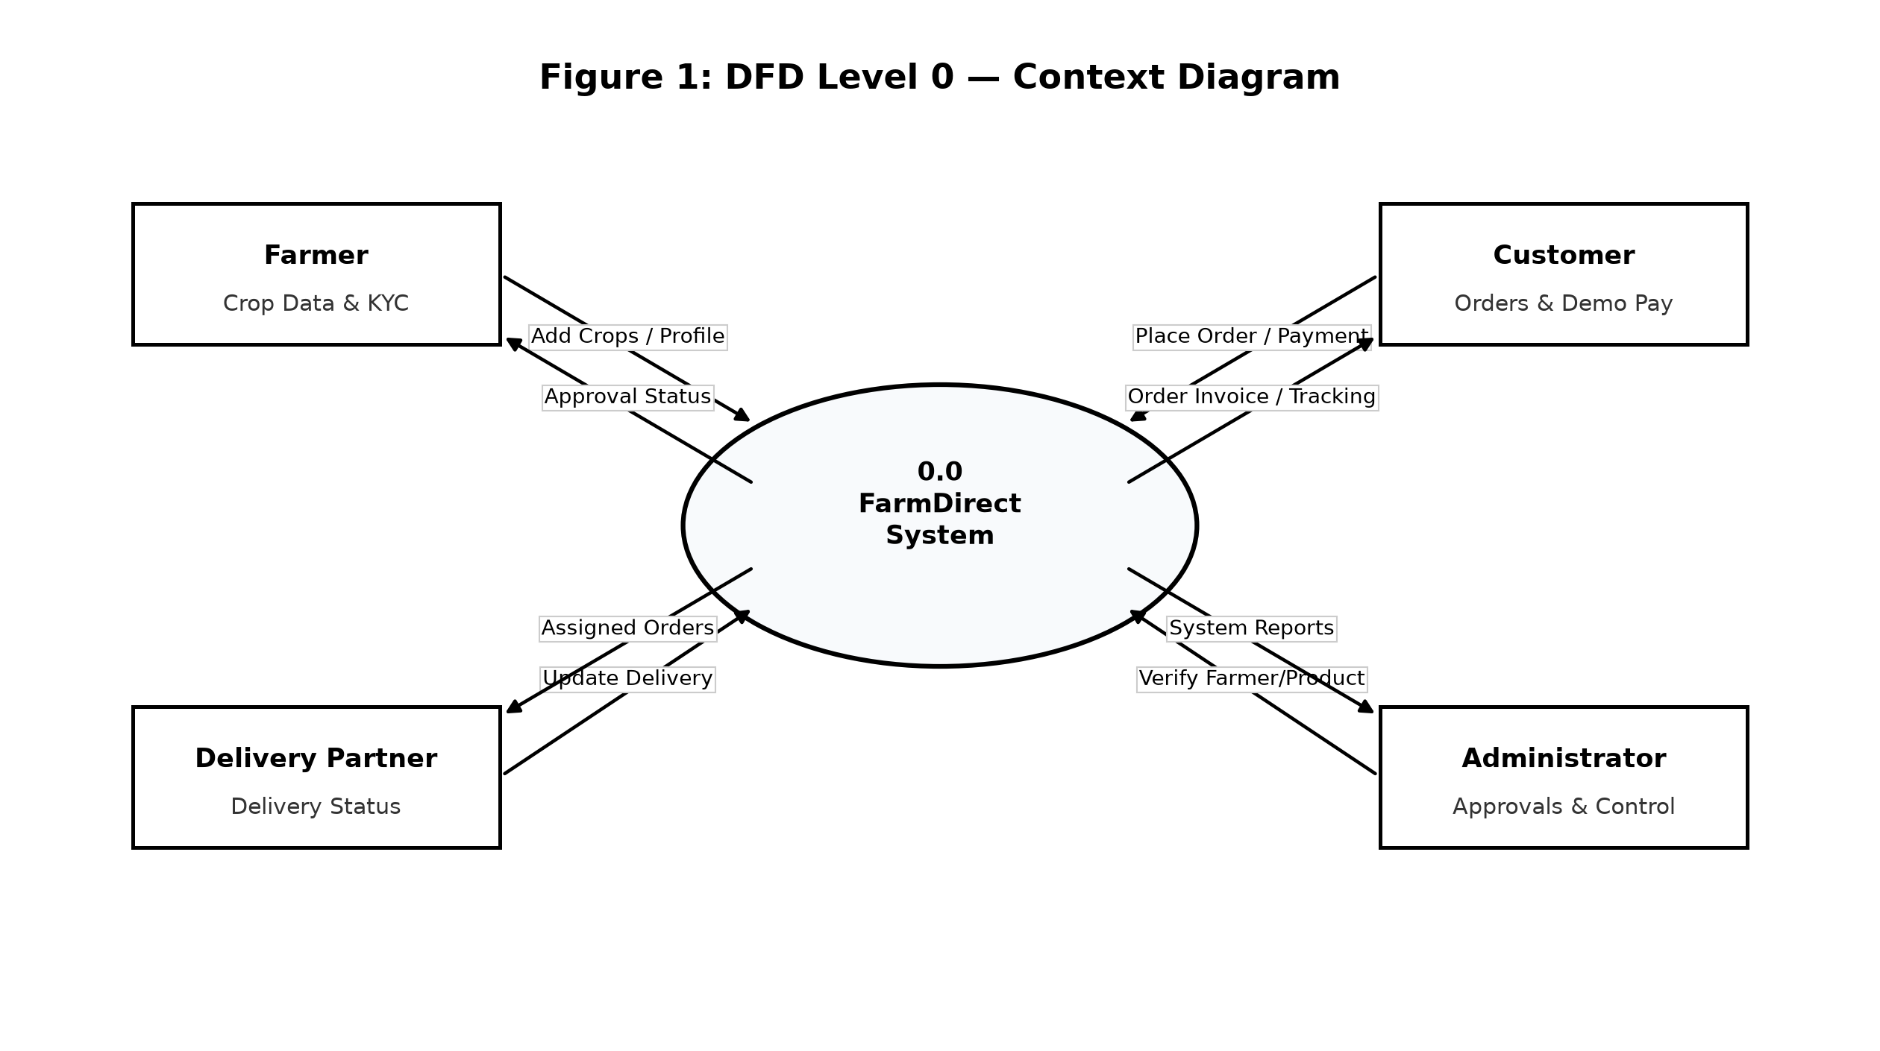
Fig. 4.1 DFD Level 0 Context Level Diagram (System Boundary and Stakeholders)
4.2.2 DFD Level 1 Subsystems Decomposition Diagram
The DFD Level 1 Diagram decomposes the central system into five core functional sub-processes (1.0 Authentication, 2.0 Farmer & Produce Approval, 3.0 Catalog Browse & Cart, 4.0 Order Placement & Demo Payment, 5.0 Delivery Logistics & Reviews) and four primary persistent data stores (D1 Users, D2 Products, D3 Orders, D4 Deliveries).
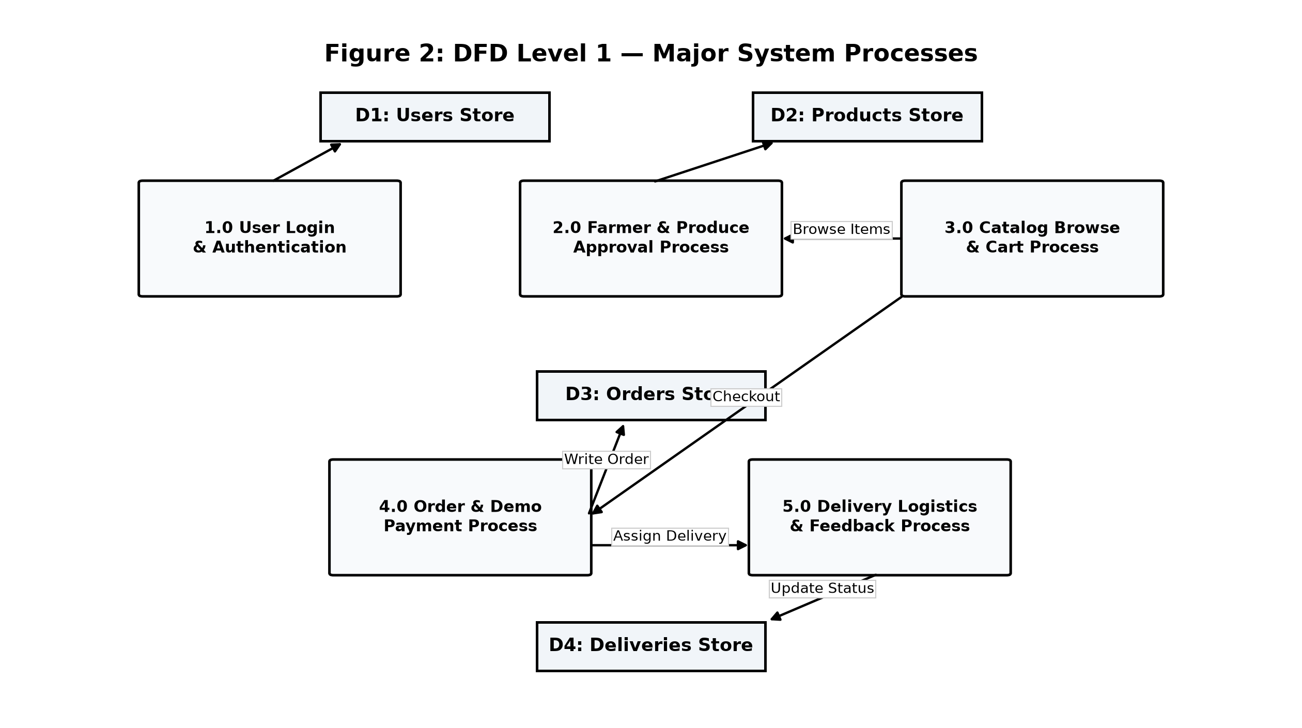
Fig. 4.2 DFD Level 1 Subsystems Decomposition Diagram (Core Modules and Data Stores)
4.2.3 DFD Level 2 Detailed Transaction Processing Flow
The DFD Level 2 Diagram specifies the granular internal decision logic when a customer initiates order checkout, illustrating stock availability validation, dynamic subtotal calculation, simulated payment dispatch, and atomic database row locking.
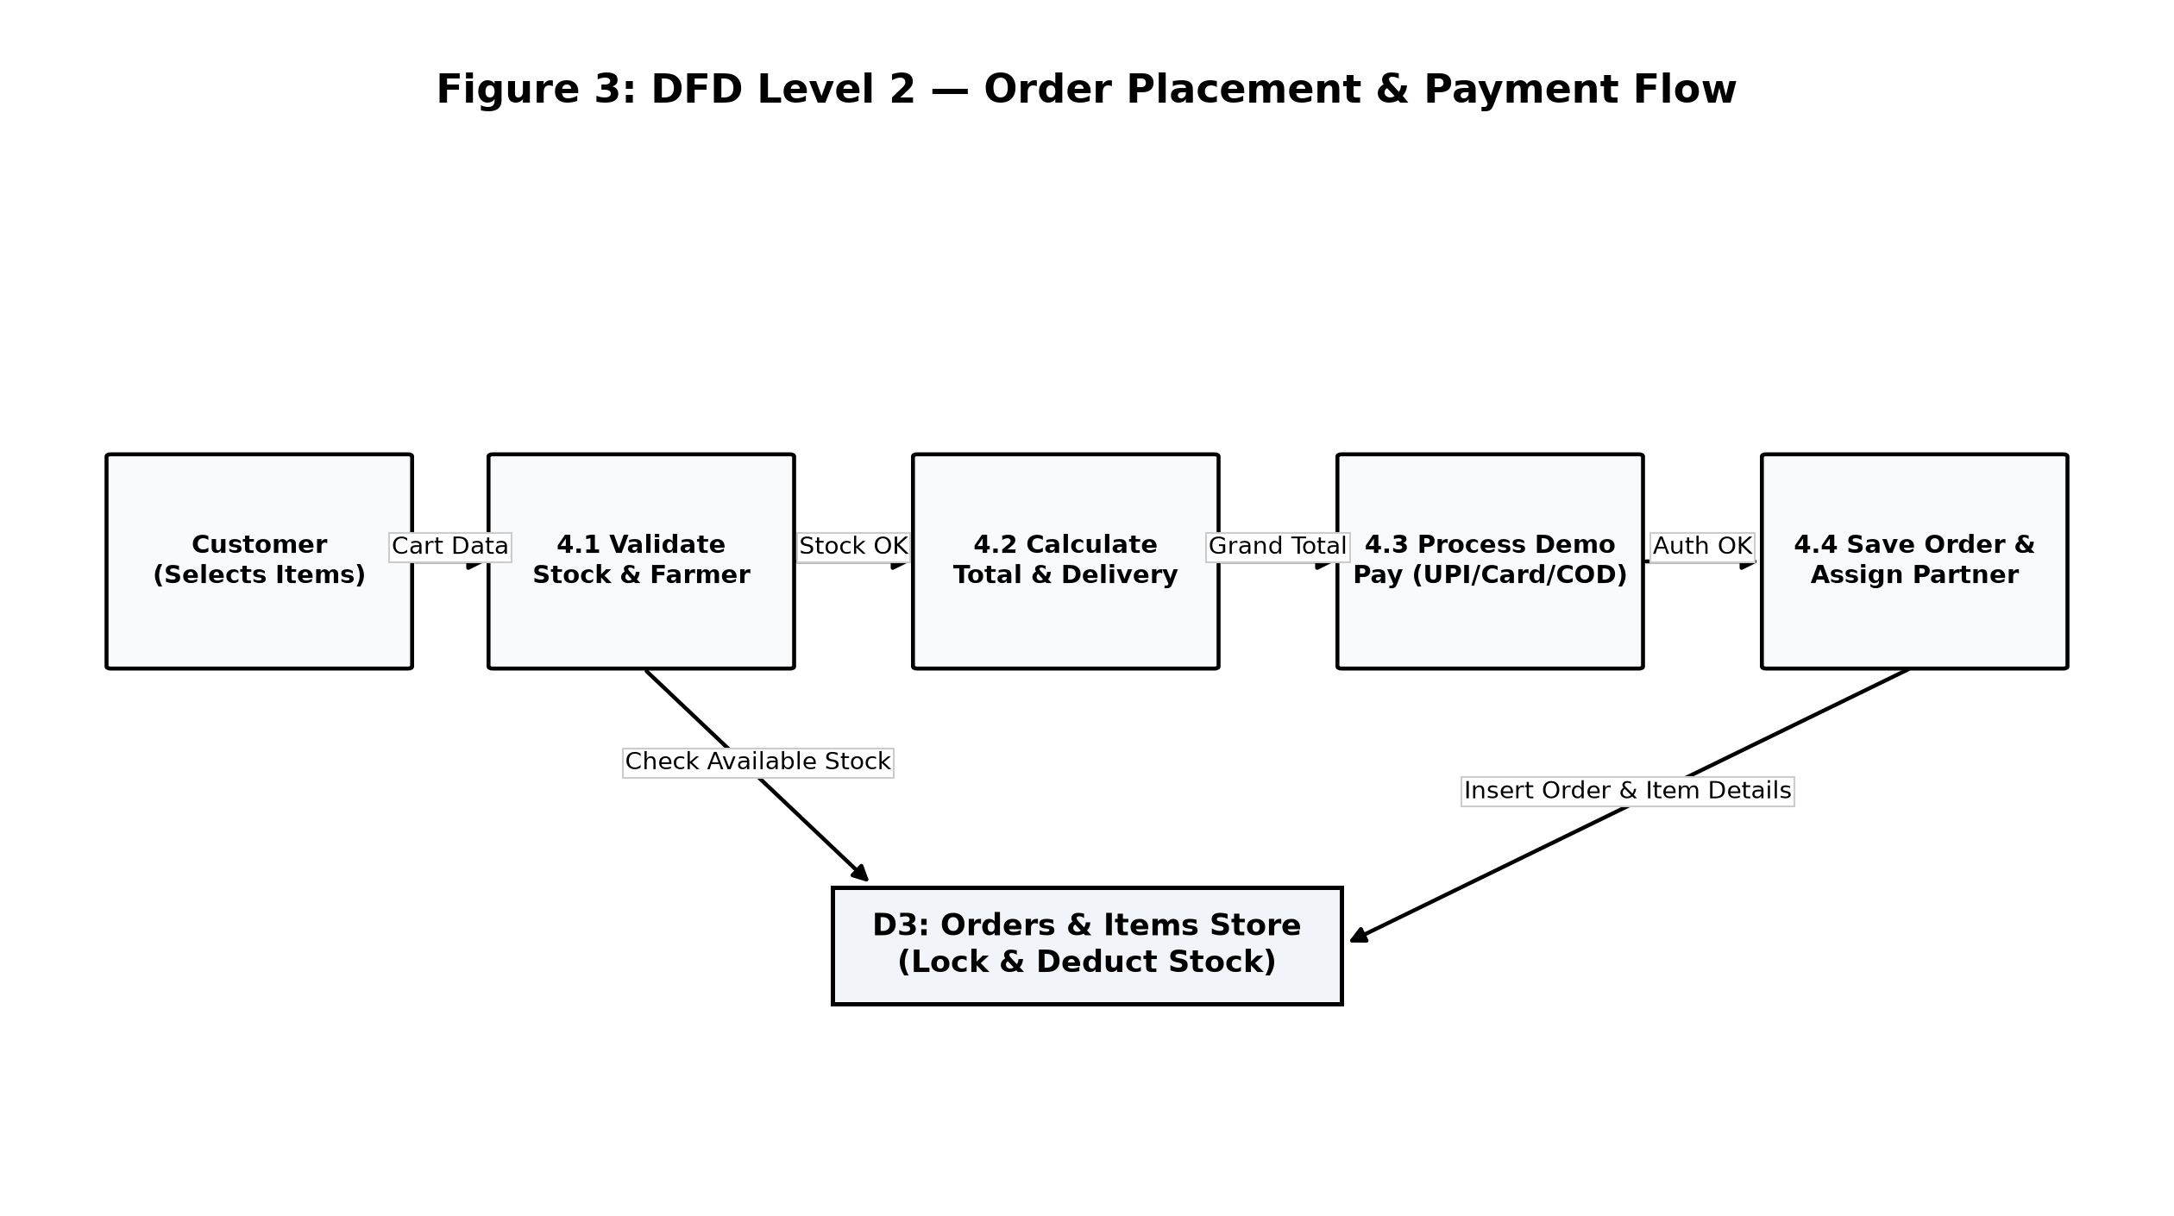
Fig. 4.3 DFD Level 2 Detailed Transaction Processing Flow (Order Checkout and Stock Reservation)
4.3 User Interface Design
Unified Modeling Language (UML) behavioral and structural diagrams capture user interactions, actor roles, entity classes, message sequencing, object collaboration, and runtime lifecycles across the application.
4.3.1 UML Use Case Diagram
The UML Use Case Diagram models functional interactions between the four primary actors and eleven core system use cases:
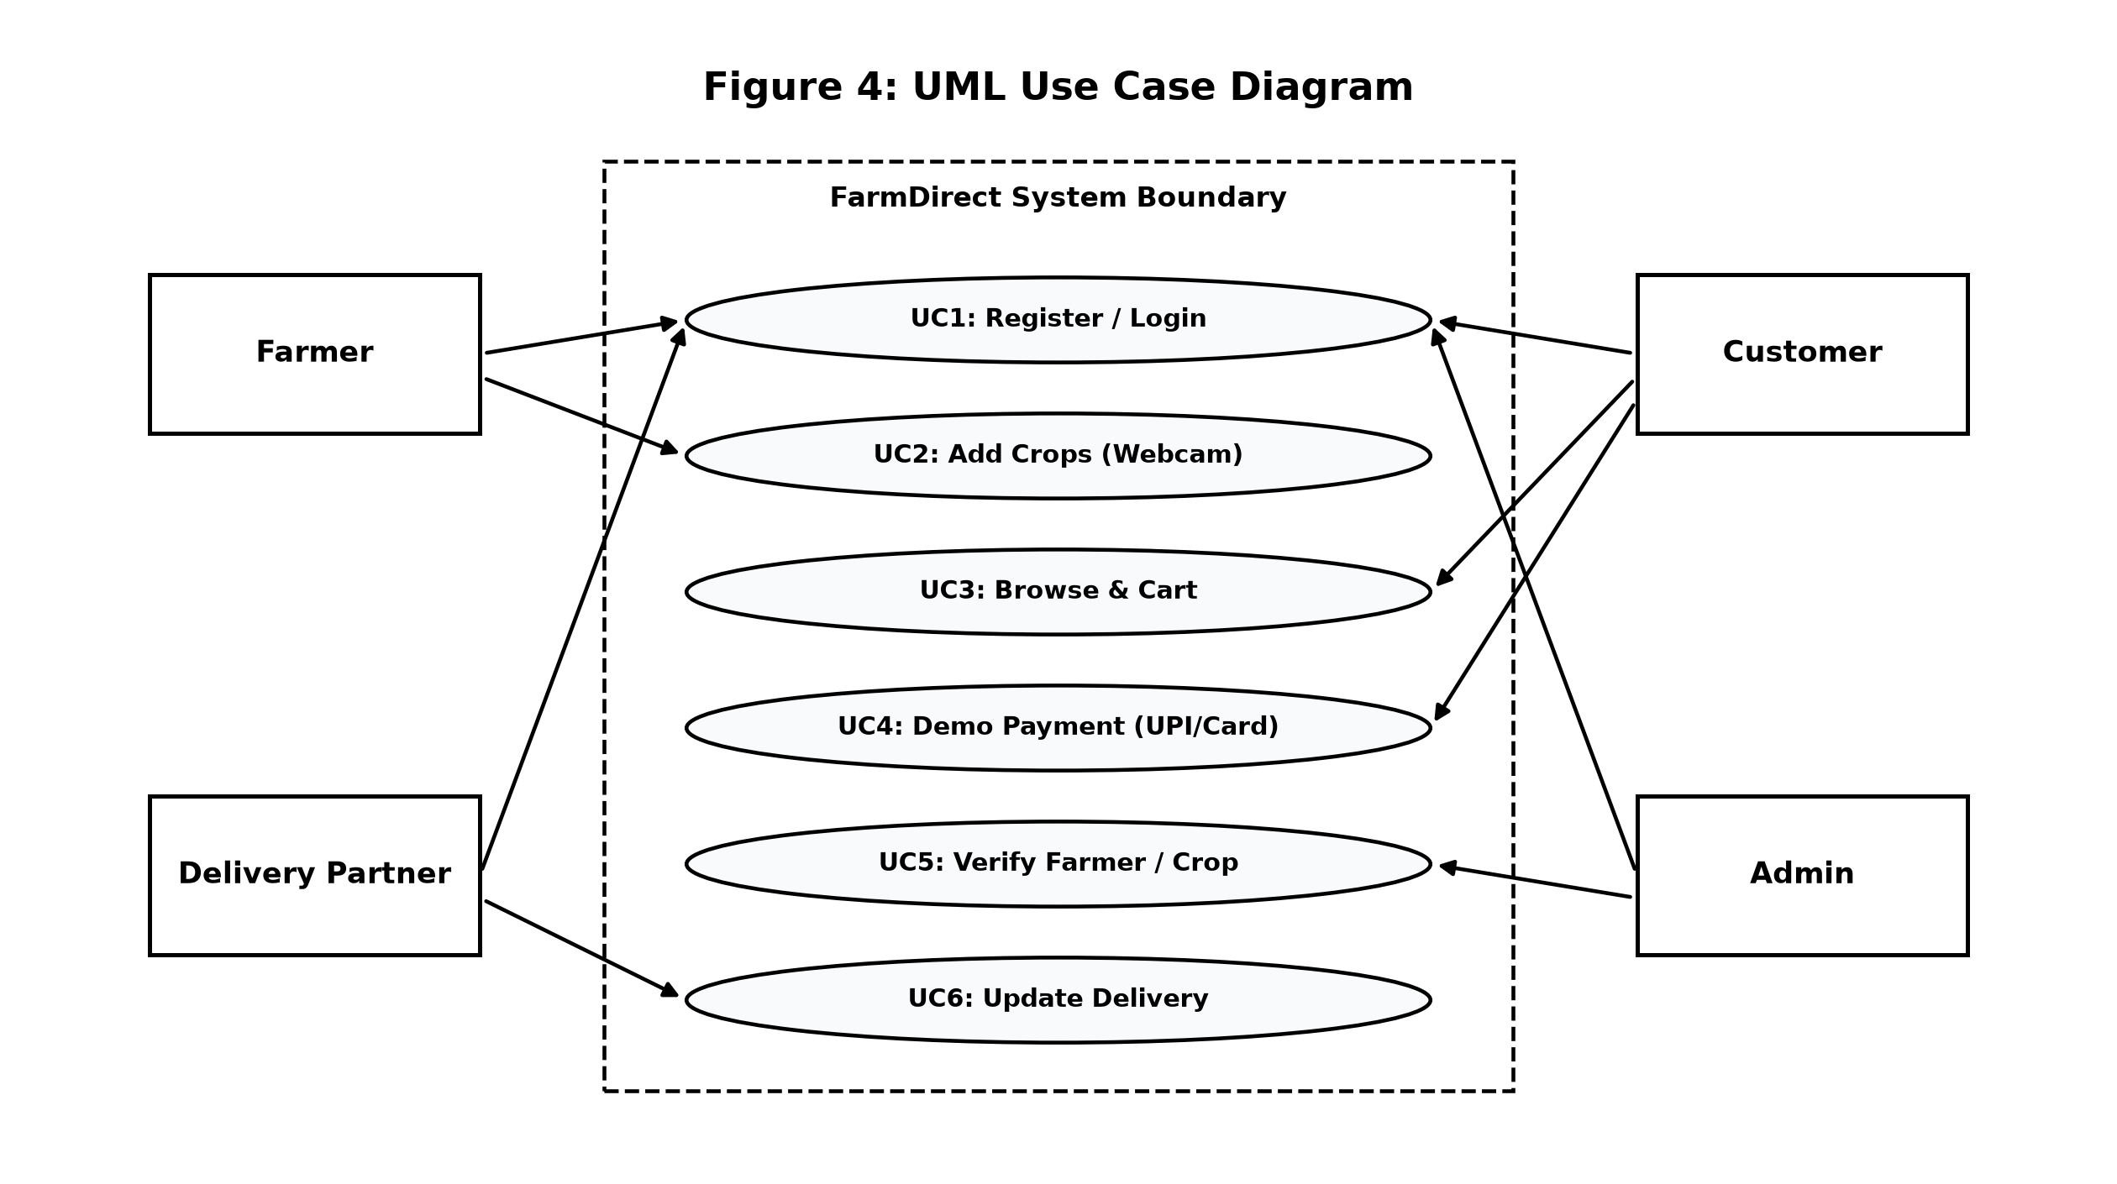
Fig. 4.4 UML Use Case Diagram (Actor Roles and Functional System Capabilities)
4.3.2 UML Class Diagram
The UML Class Diagram defines the static domain model of FarmDirect, depicting object classes (User, Farmer, Product, Category, Order, OrderItem, Delivery, Review, Message), their encapsulated attributes, public controller methods, and structural multiplicities.
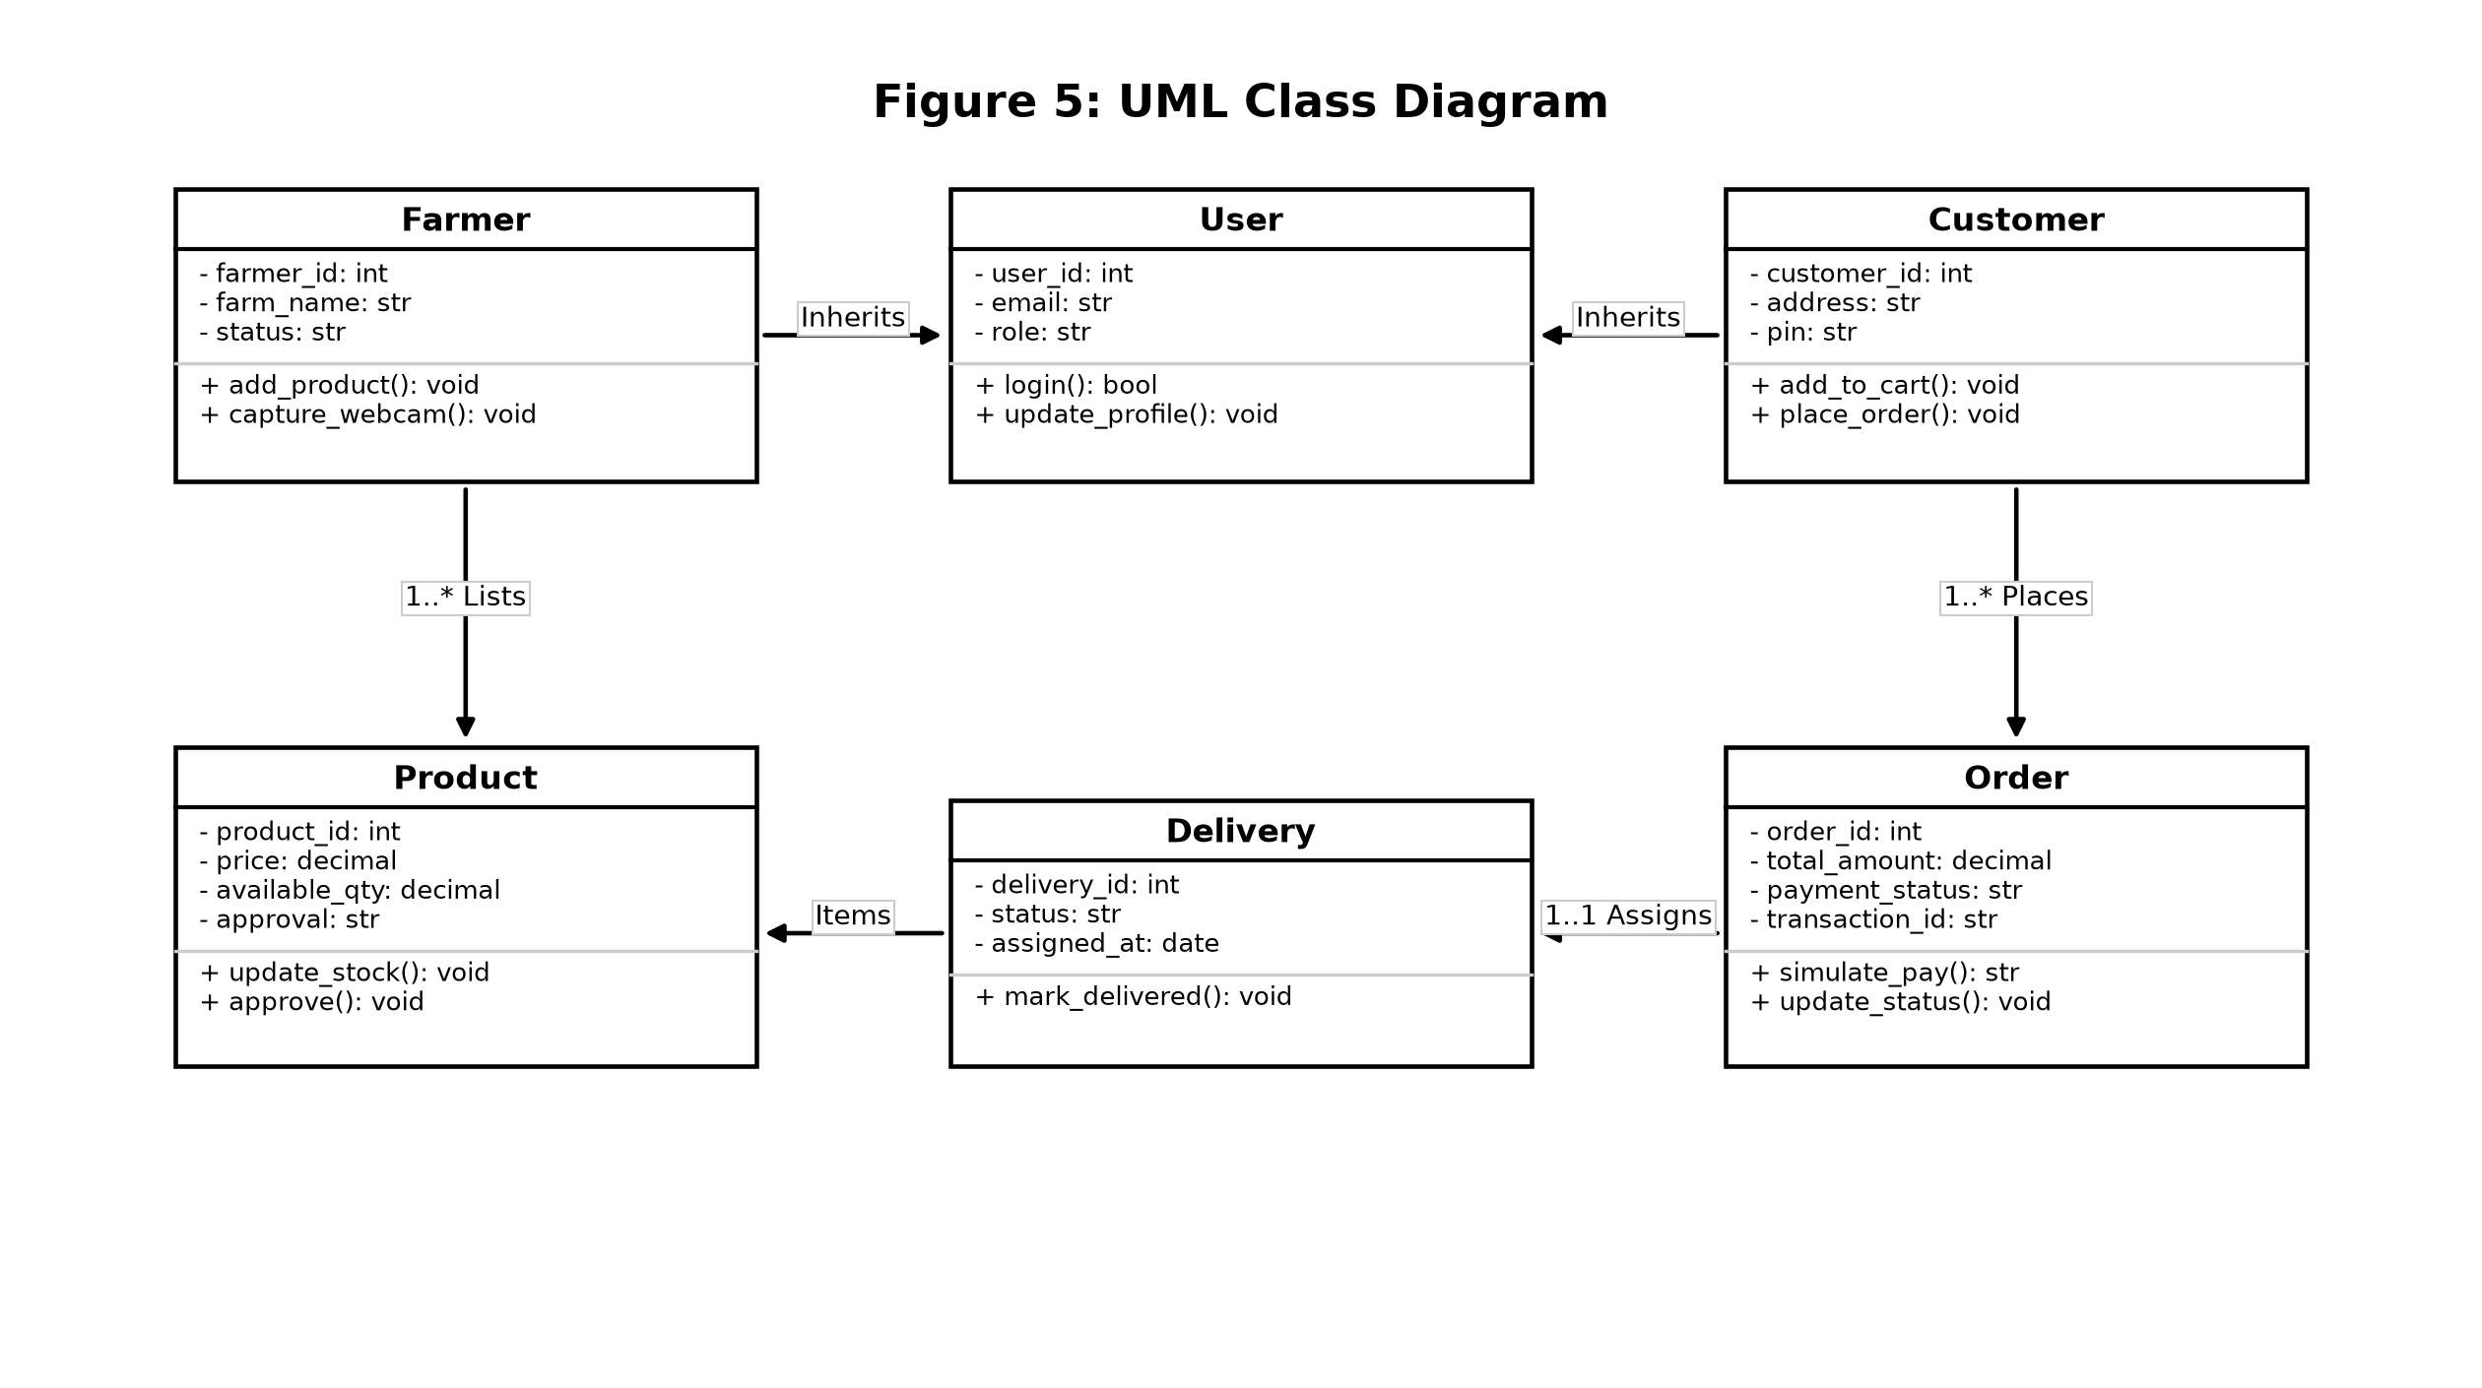
Fig. 4.5 UML Class Diagram (Domain Model, Entity Attributes, Methods, and Multiplicities)
4.3.3 UML Sequence Diagram
The UML Sequence Diagram captures the chronological message exchange across actors, controller endpoints, database services, and physical hardware APIs during crop checkout and stock reservation:
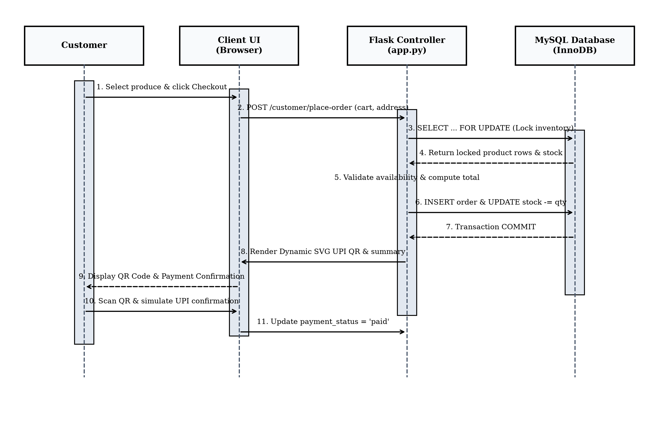
Fig. 4.6 UML Sequence Diagram (End-to-End Order & Settlement Workflow)
4.3.4 UML Collaboration Diagram
The UML Collaboration Diagram illustrates structural relationships and object communication links, highlighting real-time coordination between customer cart controllers, database locking services, and dispatch notifications:
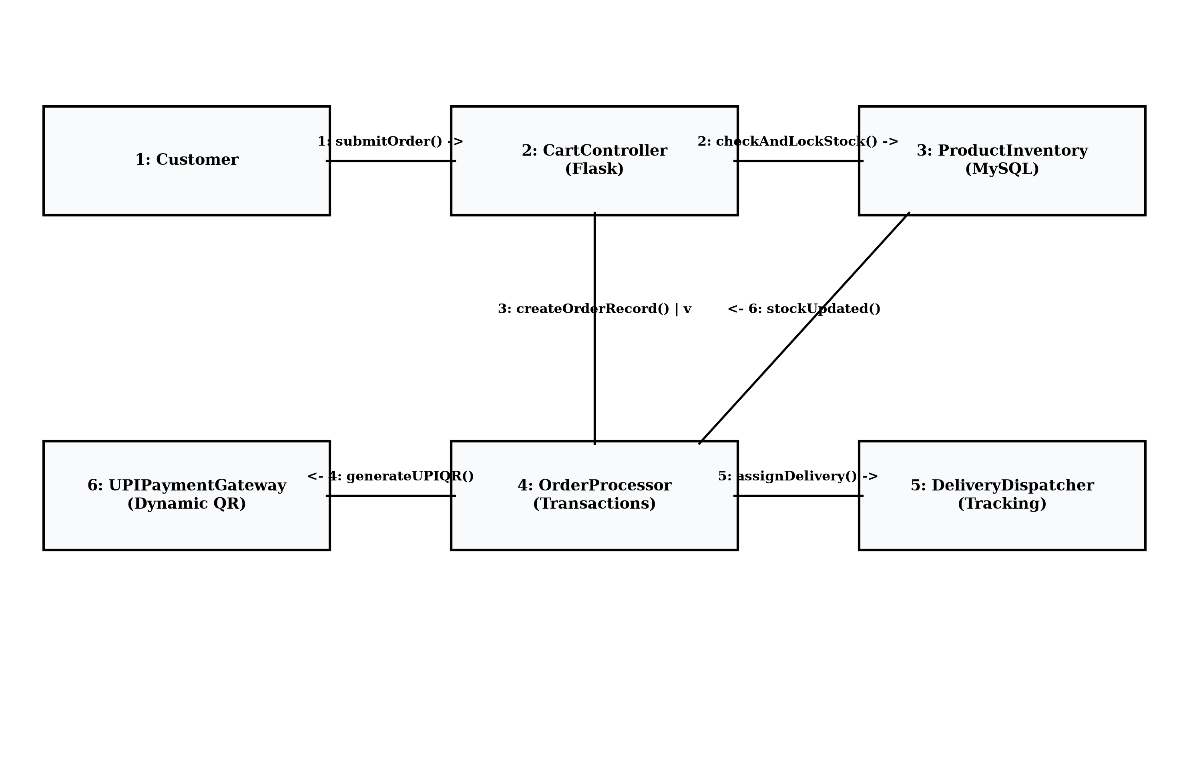
Fig. 4.7 UML Collaboration Diagram (Real-Time Communication Links)
4.3.5 UML Object Diagram
The UML Object Diagram captures a discrete runtime snapshot of active memory instances during an active marketplace harvest order:
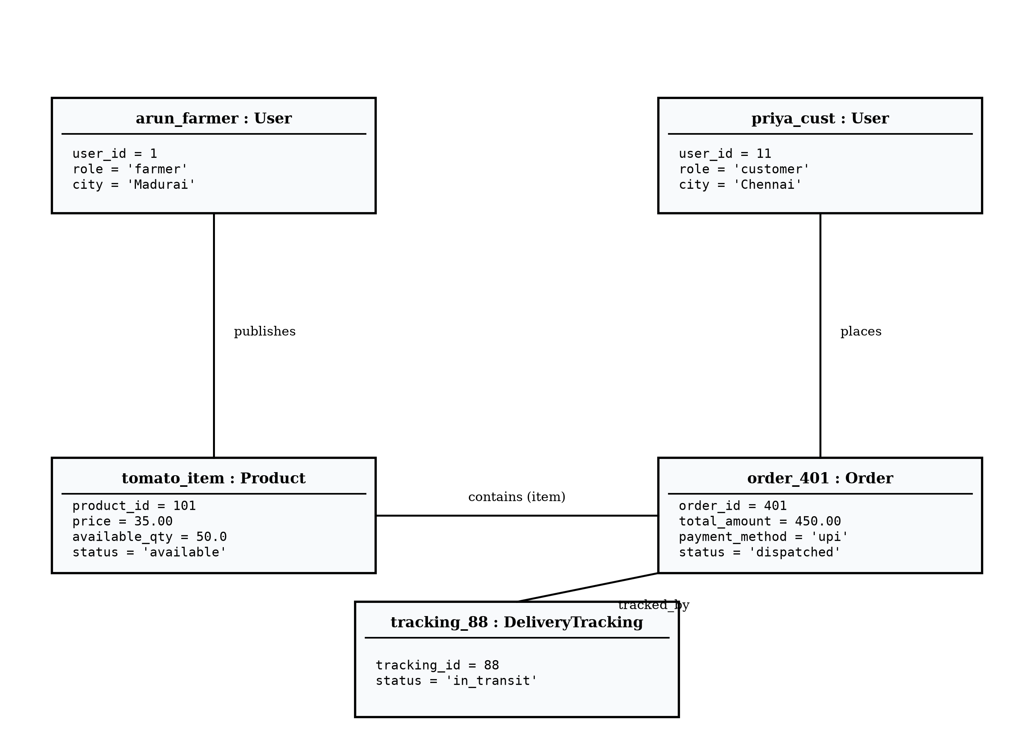
Fig. 4.8 UML Object Diagram (Runtime Instance Snapshot)
4.3.6 UML Activity / Control Flow Diagram
The UML Activity / Control Flow Diagram models sequential and conditional execution pathways from user authentication through verification, harvest listing, checkout, and final delivery dispatch:
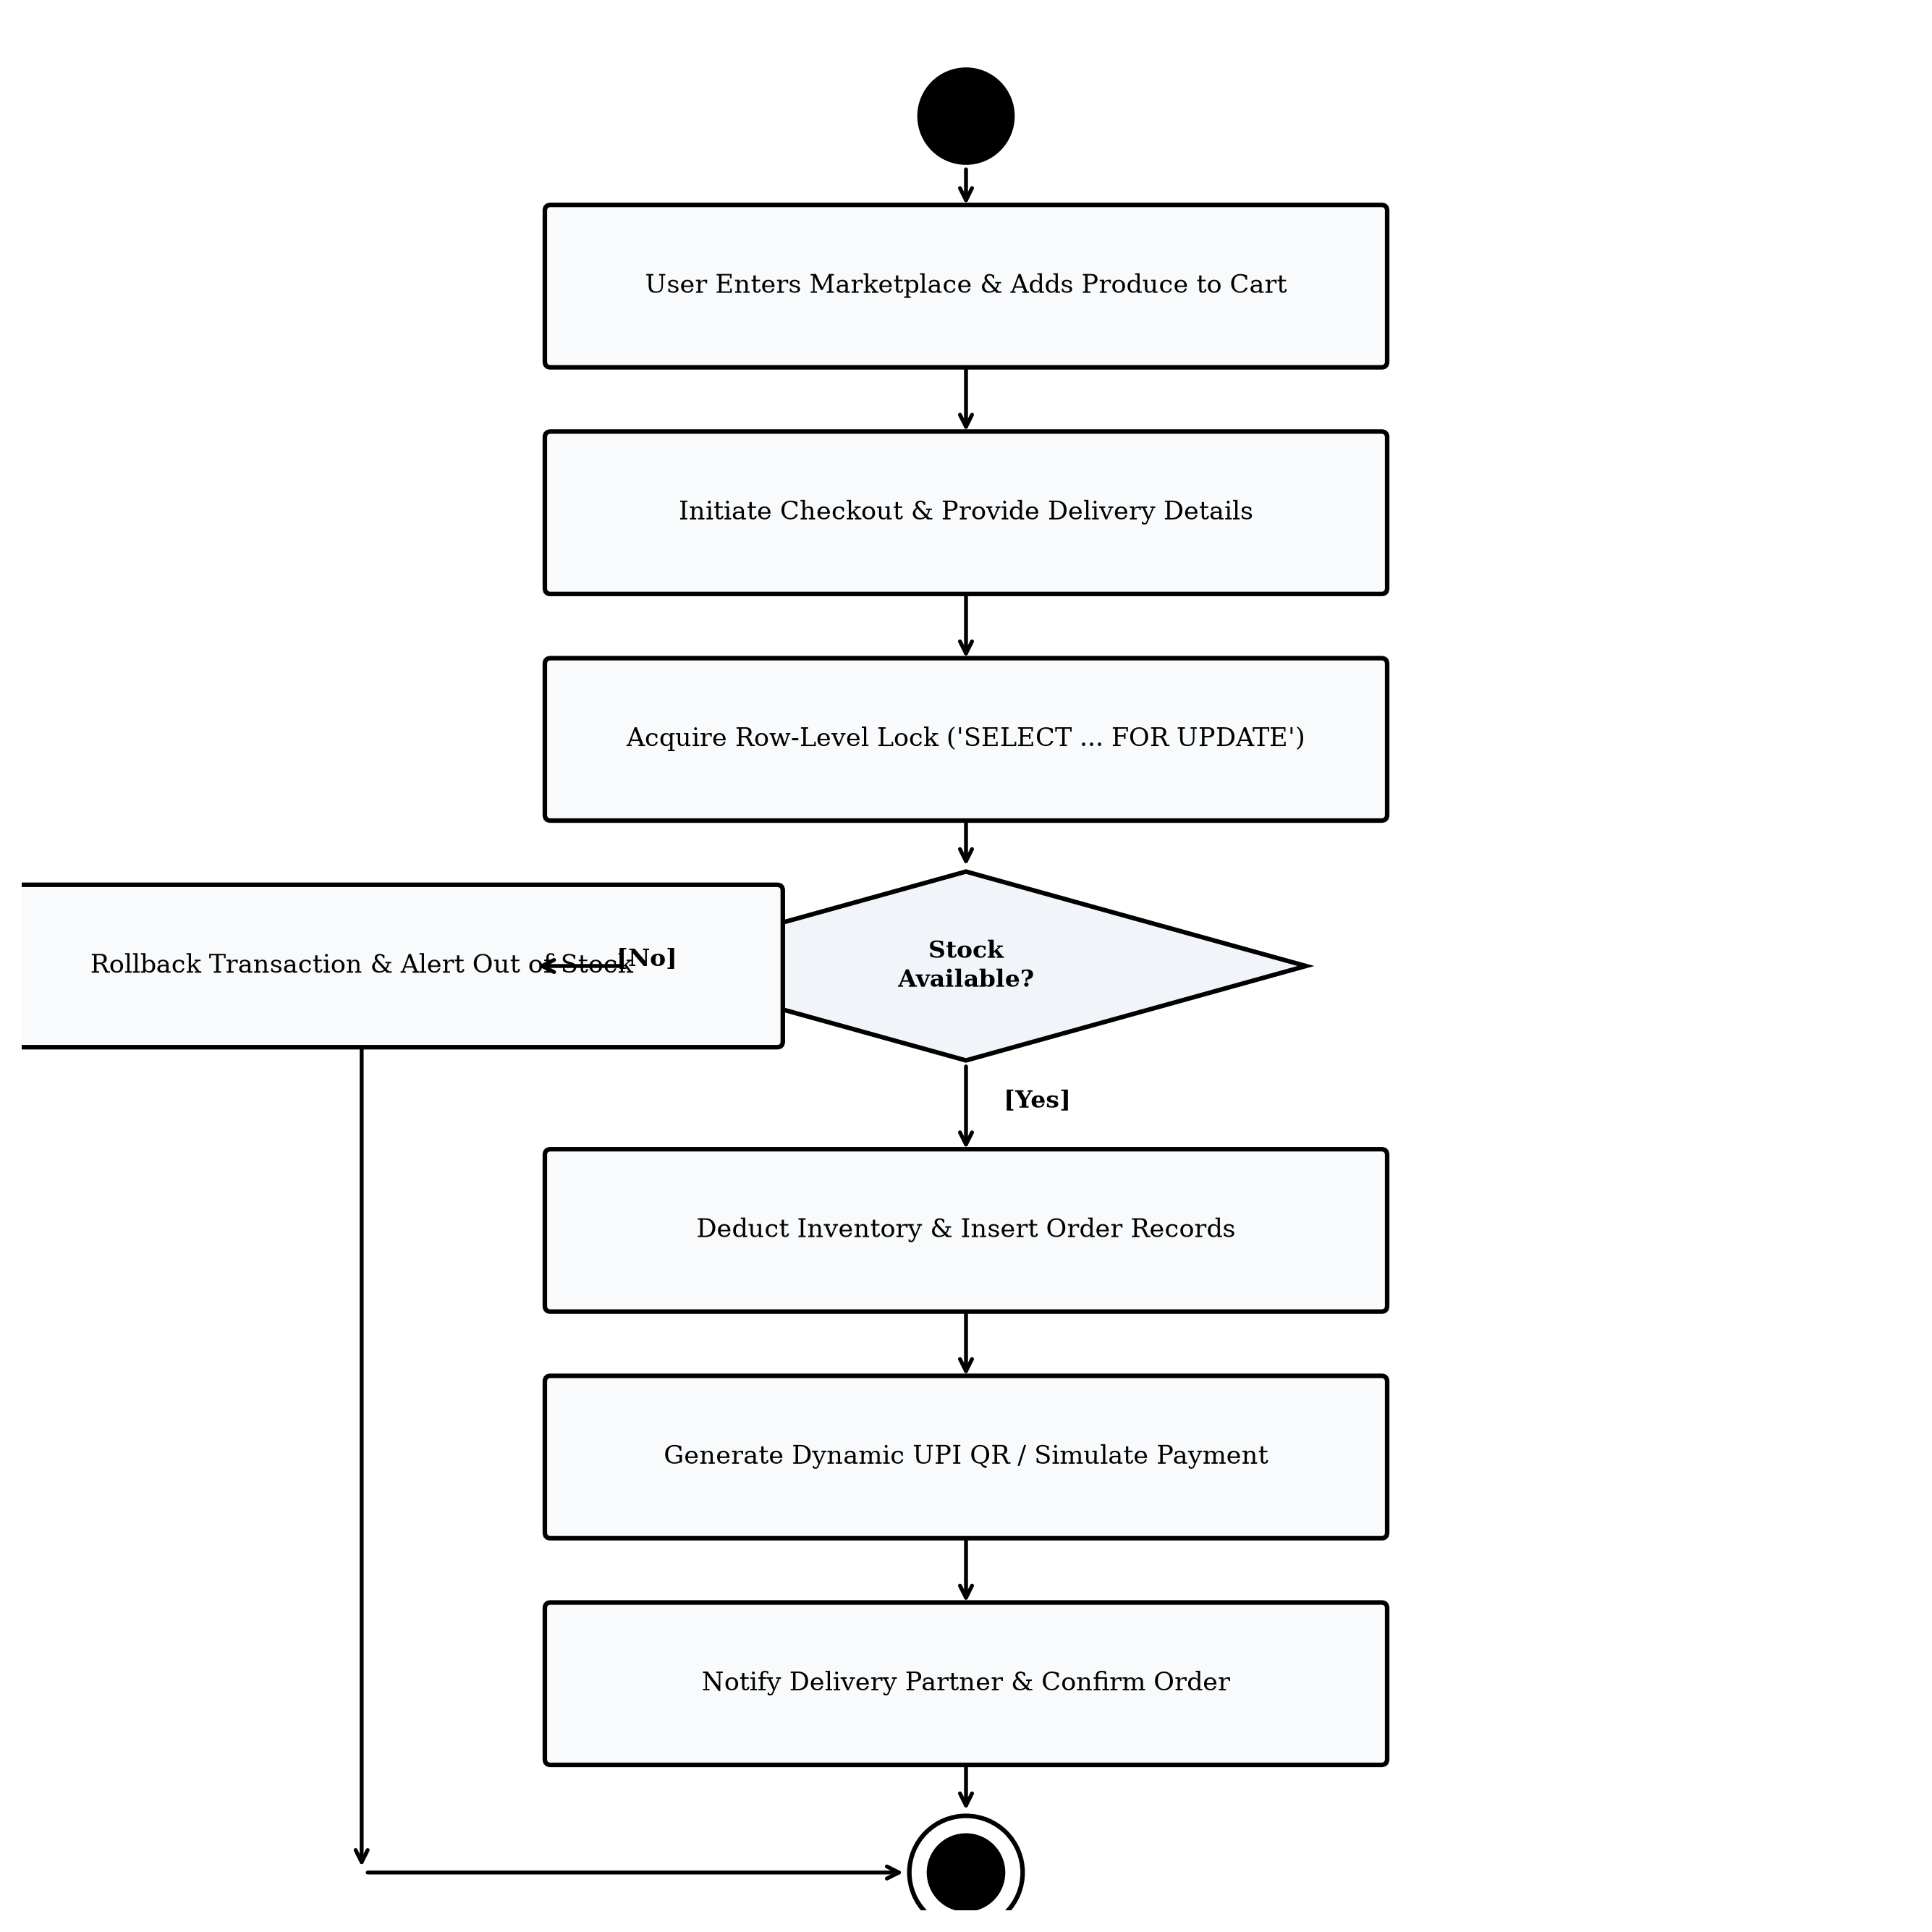
Fig. 4.9 UML Activity / Control Flow Diagram (Operational Lifecycle)
4.4 Input Design
Input design across FarmDirect focuses on data integrity, input sanitization, and seamless user experience. All form submissions are validated on both client (HTML5 form attributes) and server tiers (Python validation helpers). Specific input design features include:
• Role-Tailored Forms: Distinct registration forms capturing farm metadata for farmers (farm name, farm location, crop specializations) versus delivery coordinates for consumers.
• WebRTC Hardware Photo Capture: An intuitive modal viewfinder allowing farmers to capture live produce photos directly from laptop webcams with a single click, eliminating external file browsing.
• Numeric Quantity Incrementors: Accessible plus/minus buttons on cart items enforcing positive integer steps and blocking negative or fractional inputs.
• Strict Parameter Sanitization: Mandatory %s SQL parameterization across all endpoints to neutralize malicious SQL injection attempts.
4.5 Data and File Design
The relational persistence architecture is designed in MySQL 8.0 utilizing the InnoDB storage engine to provide strict referential integrity, foreign key cascading, and ACID transaction guarantees.
4.5.1 Relational Database Model and ER Architecture
The Entity-Relationship model establishes relational associations across users, farmer profiles, crop categories, produce inventories, order items, and dispatch logs:
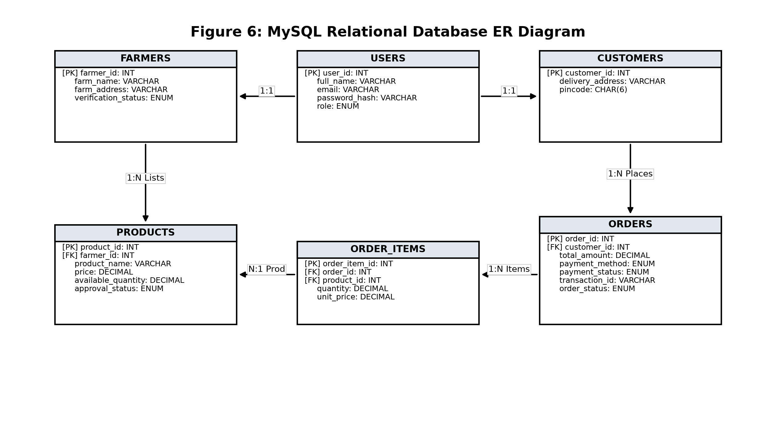
Fig. 4.10 MySQL Relational Entity-Relationship (E-R) Diagram (3NF Normalized Schema)
4.5.2 Functional Dependencies and Normalization to 3NF
The relational schema was formally normalized to Third Normal Form (3NF) to eliminate insertion, update, and deletion anomalies:
• First Normal Form (1NF): All attributes contain strictly atomic, indivisible values. Repeating groups such as order line items are decomposed into child table order_items.
• Second Normal Form (2NF): Eliminates partial key dependencies; all non-prime attributes in composite-key relations depend fully on the complete candidate key.
• Third Normal Form (3NF): Eliminates transitive functional dependencies. Attributes such as customer address depend strictly on customer_id, not on order transaction attributes.
4.5.3 Structured Data Dictionary
The comprehensive data dictionary tables define primary keys [PK], foreign keys [FK], data types, and operational constraints across all relational entities:
Table 4.2 users (System Stakeholders and Authentication Credentials)
Column Name | Data Type | Constraints | Description
user_id | INT AUTO_INCREMENT | PRIMARY KEY | Unique identifier for system user
full_name | VARCHAR(100) | NOT NULL | Full legal name of the user
email | VARCHAR(100) | NOT NULL, UNIQUE | User email used for authentication
password_hash | VARCHAR(255) | NOT NULL | Werkzeug Scrypt/PBKDF2 salted hash
role | ENUM('admin','farmer','customer','delivery') | NOT NULL | Role-based access control discriminator
phone | VARCHAR(20) | DEFAULT NULL | Contact phone number for notifications
created_at | DATETIME | DEFAULT CURRENT_TIMESTAMP | Account creation timestamp

Table 4.3 farmer_profiles (Cultivator Verification & Farm Metadata)
Column Name | Data Type | Constraints | Description
farmer_id | INT | PRIMARY KEY, FK -> users(user_id) | 1:1 link to base user account
farm_name | VARCHAR(100) | NOT NULL | Registered operational name of farm
farm_location | TEXT | NOT NULL | Physical village/district address
verification_status | ENUM('pending','verified','rejected') | DEFAULT 'pending' | Administrative identity KYC status
verified_at | DATETIME | DEFAULT NULL | Timestamp when admin approved farmer

Table 4.4 categories (Master Agricultural Crop Classifications)
Column Name | Data Type | Constraints | Description
category_id | INT AUTO_INCREMENT | PRIMARY KEY | Unique category identifier
category_name | VARCHAR(50) | NOT NULL, UNIQUE | Produce classification (Vegetables, Fruits, Grains)
description | TEXT | DEFAULT NULL | Category scope and seasonal descriptions

Table 4.5 products (Agricultural Produce Inventory & Catalog)
Column Name | Data Type | Constraints | Description
product_id | INT AUTO_INCREMENT | PRIMARY KEY | Unique crop listing identifier
farmer_id | INT | NOT NULL, FK -> users(user_id) | Cultivator who harvested the crop
category_id | INT | NOT NULL, FK -> categories | Associated agricultural category
product_name | VARCHAR(100) | NOT NULL | Common commercial name of harvest
unit | VARCHAR(20) | DEFAULT 'kg' | Unit of measure (kg, bunch, box)
price | DECIMAL(10,2) | NOT NULL, CHECK (price >= 0) | Farm-gate unit retail price in INR
available_quantity | DECIMAL(10,2) | NOT NULL, CHECK (qty >= 0) | Real-time harvest inventory stock
approval_status | ENUM('pending','approved','rejected') | DEFAULT 'pending' | Admin quality gatekeeper status
product_status | ENUM('available','out_of_stock') | DEFAULT 'available' | Catalog visibility availability flag
image_filename | VARCHAR(255) | DEFAULT 'default_crop.jpg' | Static media storage file path

Table 4.6 orders (Consumer Purchase Orders and Payment Status)
Column Name | Data Type | Constraints | Description
order_id | INT AUTO_INCREMENT | PRIMARY KEY | Unique order transaction identifier
customer_id | INT | NOT NULL, FK -> users(user_id) | Consumer who placed the order
total_amount | DECIMAL(10,2) | NOT NULL | Total payable invoice amount in INR
order_status | ENUM('placed','confirmed','dispatched','delivered') | DEFAULT 'placed' | Synchronized order lifecycle state
payment_method | ENUM('cod','upi','card') | NOT NULL | Simulated payment mode selected
payment_status | ENUM('pending','paid') | DEFAULT 'pending' | Financial settlement status flag
delivery_address | TEXT | NOT NULL | Household delivery dropoff destination
created_at | DATETIME | DEFAULT CURRENT_TIMESTAMP | Order placement timestamp

Table 4.7 order_items (Itemized Order Line Items & Quantities)
Column Name | Data Type | Constraints | Description
order_item_id | INT AUTO_INCREMENT | PRIMARY KEY | Unique line item identifier
order_id | INT | NOT NULL, FK -> orders ON DELETE CASCADE | Parent purchase order association
product_id | INT | NOT NULL, FK -> products | Referenced agricultural crop
quantity | DECIMAL(10,2) | NOT NULL, CHECK (quantity > 0) | Purchased crop quantity
unit_price | DECIMAL(10,2) | NOT NULL | Frozen unit price at checkout time
item_total | DECIMAL(10,2) | NOT NULL | Calculated item subtotal (qty * price)

Table 4.8 deliveries (Dispatch Allocation & Logistics Tracking)
Column Name | Data Type | Constraints | Description
delivery_id | INT AUTO_INCREMENT | PRIMARY KEY | Unique dispatch delivery identifier
order_id | INT | NOT NULL, UNIQUE, FK -> orders | Single assigned purchase order
delivery_partner_id | INT | NOT NULL, FK -> users(user_id) | Assigned logistics dispatch driver
current_status | ENUM('assigned','picked_up','in_transit','delivered') | DEFAULT 'assigned' | Physical fulfillment milestone
assigned_at | DATETIME | DEFAULT CURRENT_TIMESTAMP | Driver allocation timestamp
delivered_at | DATETIME | DEFAULT NULL | Doorstep handover completion timestamp

Table 4.9 reviews (Post-Fulfillment Consumer Quality Feedback)
Column Name | Data Type | Constraints | Description
review_id | INT AUTO_INCREMENT | PRIMARY KEY | Unique review identifier
product_id | INT | NOT NULL, FK -> products | Reviewed agricultural harvest
customer_id | INT | NOT NULL, FK -> users(user_id) | Authoring consumer account
rating | INT | NOT NULL, CHECK (rating BETWEEN 1 AND 5) | Quality rating score (1 to 5 stars)
review_text | TEXT | DEFAULT NULL | Detailed customer feedback comments
created_at | DATETIME | DEFAULT CURRENT_TIMESTAMP | Review publication timestamp

4.5.4 Database Safety, Indexing, and ACID Reliability Controls
All tables utilize the MySQL InnoDB storage engine supporting ACID transactions, foreign key constraints, and crash-safe write-ahead logging. B-tree indexes are established on frequently queried lookup columns: products(approval_status, category_id), orders(customer_id, order_status), and deliveries(delivery_partner_id, current_status), ensuring high-speed catalog querying.
4.6 Process Design and Navigation
System navigation is structured into role-tailored view hierarchies with responsive top navigation bars dynamically rendering options according to active session roles. Farmers navigate between Crop Catalog, Add Produce (Webcam), and Orders; Customers access Browse Marketplace, Cart, Checkout, and Order History; Delivery Partners view Active Dispatches; and Administrators access Farmer Approvals, Crop Approvals, and Platform Telemetry.
5. IMPLEMENTATION
5.1 Implementation Approach & Engineering Workflow
The implementation of FarmDirect follows modular clean architecture standards. Presentation markup (Jinja2 templates, Bootstrap 5), business controllers (Flask route blueprints), and relational persistence (MySQL database connector) are decoupled. Development followed a feature-branch Git workflow where each feature was validated via automated unit checks before integration into the primary codebase.
5.2 Software Reuse Strategy
Software reuse is maximized by leveraging proven industry open-source libraries: Werkzeug Security for Scrypt cryptographic salting and hashing; mysql-connector-python for pooled database cursor management; Bootstrap 5.3 for responsive grid layouts and modal dialogs; and the standard HTML5 MediaDevices API for hardware webcam capture.
5.3 Design Patterns Applied
The codebase systematically implements established software design patterns: Model-View-Controller (MVC) separating presentation from controller logic; Repository Pattern abstracting SQL execution in utils/db.py; Strategy Pattern dynamically handling simulated payments (COD, dynamic UPI QR, card); Decorator Pattern enforcing role-based access control (@role_required); and Singleton Pattern managing configuration settings in config.py.
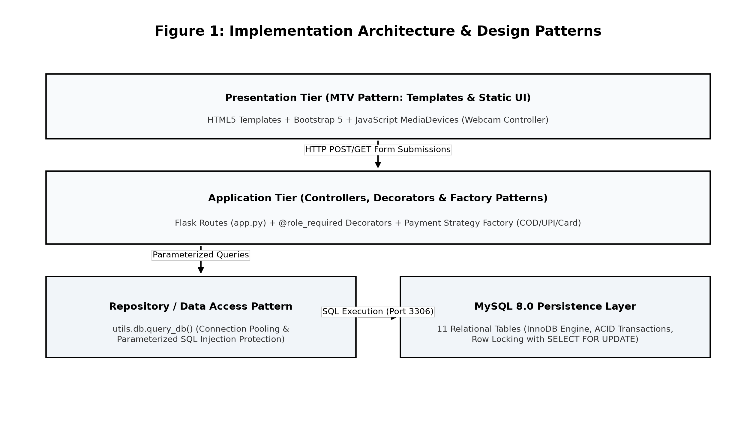
Fig. 5.1 Three-Tier Implementation Architecture and Design Pattern Interaction Flow
5.4 Key Implementation Algorithms and Code Blocks
Core algorithmic innovations implemented across the platform are illustrated below:
Listing 5.1: Atomic Inventory Concurrency Control via Pessimistic Row-Level Locking (app.py):
@app.route('/customer/checkout', methods=['POST'])
@role_required('customer')
def place_order():
cart = session.get('cart', {})
conn = get_db_connection()
cursor = conn.cursor(dictionary=True)
try:
conn.start_transaction()
# Pessimistic row locking on requested product inventory
for prod_id, qty in cart.items():
cursor.execute('SELECT available_quantity, price FROM products WHERE product_id = %s FOR UPDATE', (prod_id,))
item = cursor.fetchone()
if not item or item['available_quantity'] < qty:
conn.rollback()
flash('Stock depleted during checkout. Order cancelled.', 'danger')
return redirect(url_for('customer_cart'))
cursor.execute('UPDATE products SET available_quantity = available_quantity - %s WHERE product_id = %s', (qty, prod_id))
conn.commit()
finally:
cursor.close()
conn.close()
Listing 5.1 Python / Flask - Atomic Row-Level Concurrency Control
Listing 5.2: Client-Side Laptop Webcam Hardware Integration (static/js/script.js):
const FarmDirectWebcam = {
stream: null,
start: async function() {
this.stream = await navigator.mediaDevices.getUserMedia({ video: { width: 1280, height: 720 }, audio: false });
document.getElementById('webcamVideo').srcObject = this.stream;
},
capture: function() {
const video = document.getElementById('webcamVideo'), canvas = document.getElementById('webcamCanvas');
canvas.width = video.videoWidth; canvas.height = video.videoHeight;
canvas.getContext('2d').drawImage(video, 0, 0);
canvas.toBlob((blob) => {
const file = new File([blob], 'harvest_photo.jpg', { type: 'image/jpeg' });
const dt = new DataTransfer(); dt.items.add(file);
document.getElementById('cropImageInput').files = dt.files;
this.stop();
}, 'image/jpeg', 0.90);
},
stop: function() {
if (this.stream) this.stream.getTracks().forEach(t => t.stop());
}
};
Listing 5.2 JavaScript - HTML5 WebRTC MediaDevices Camera Capture
5.5 Relational Schema DDL and Constraints
The foundational MySQL 8.0 DDL statements establishing relational tables, primary keys, and cascading foreign key constraints are listed below:
CREATE TABLE users (
user_id INT AUTO_INCREMENT PRIMARY KEY,
full_name VARCHAR(100) NOT NULL,
email VARCHAR(100) NOT NULL UNIQUE,
password_hash VARCHAR(255) NOT NULL,
role ENUM('admin','farmer','customer','delivery') NOT NULL
);
CREATE TABLE products (
product_id INT AUTO_INCREMENT PRIMARY KEY,
farmer_id INT NOT NULL, category_id INT NOT NULL,
product_name VARCHAR(100) NOT NULL, price DECIMAL(10,2) NOT NULL,
available_quantity DECIMAL(10,2) NOT NULL,
approval_status ENUM('pending','approved','rejected') DEFAULT 'pending',
FOREIGN KEY (farmer_id) REFERENCES users(user_id) ON DELETE CASCADE
);
Listing 5.3 MySQL 8.0 Relational Table Definitions (InnoDB Engine)
5.6 Graphical User Interface Output Screens
The operational screen progression implemented for FarmDirect demonstrates complete end-to-end functionality across core user journeys:
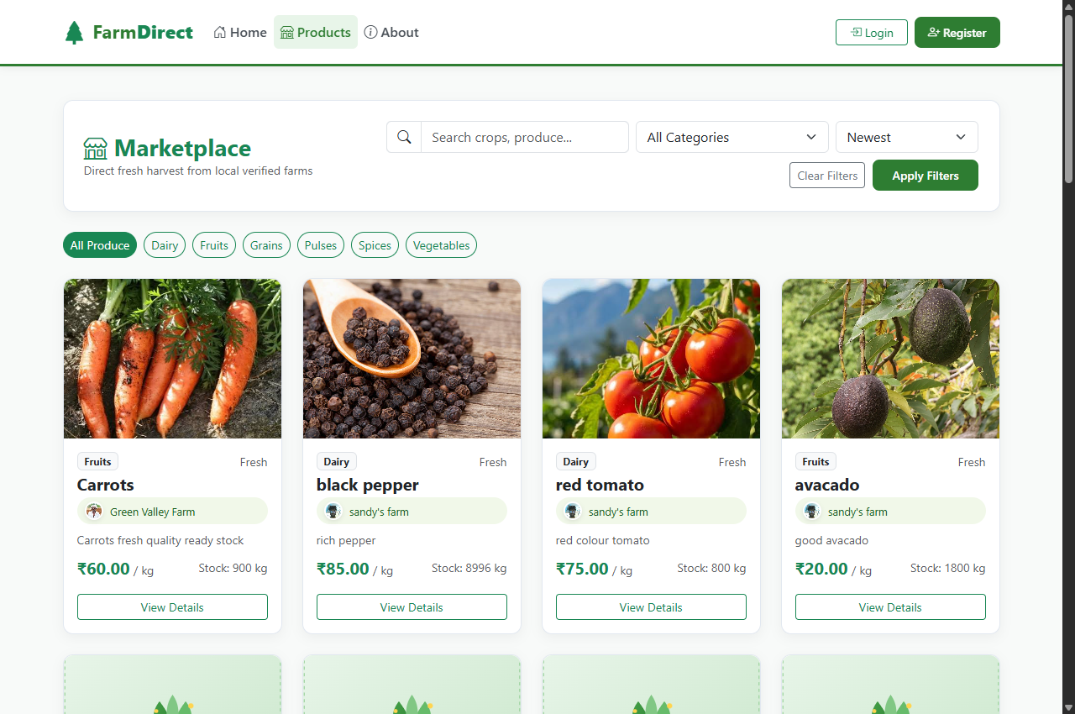
Photo 5.1 Live Consumer Agricultural Marketplace Catalog and Search Interface
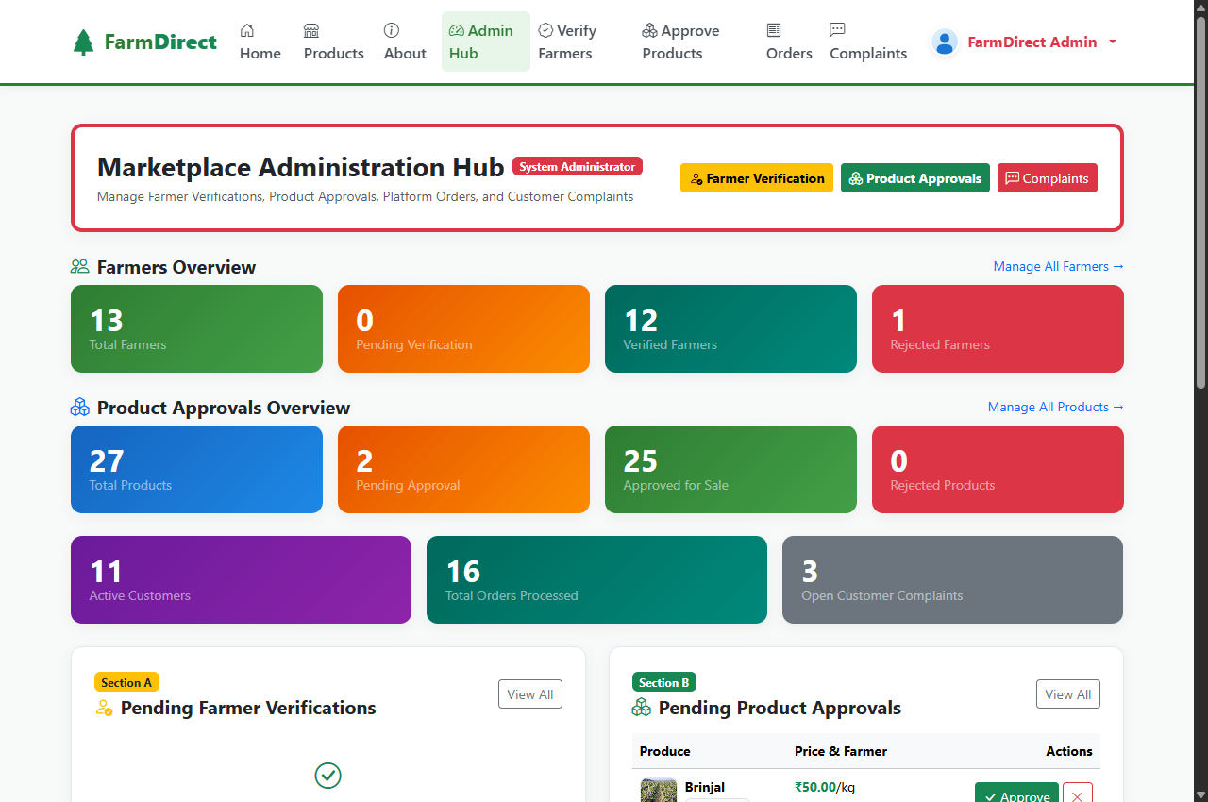
Photo 5.2 Live Administrator Governance Dashboard - Farmer Verification and Crop Approval Interface
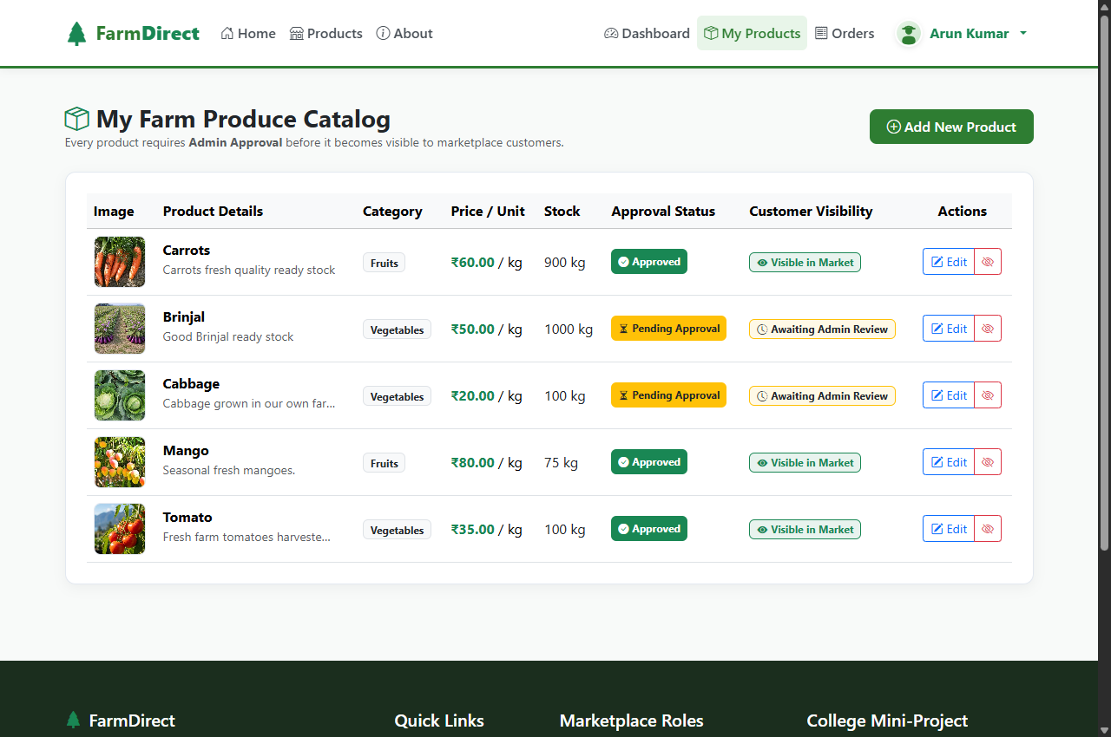
Photo 5.3 Live Farmer Inventory Management and Produce Listing Portal
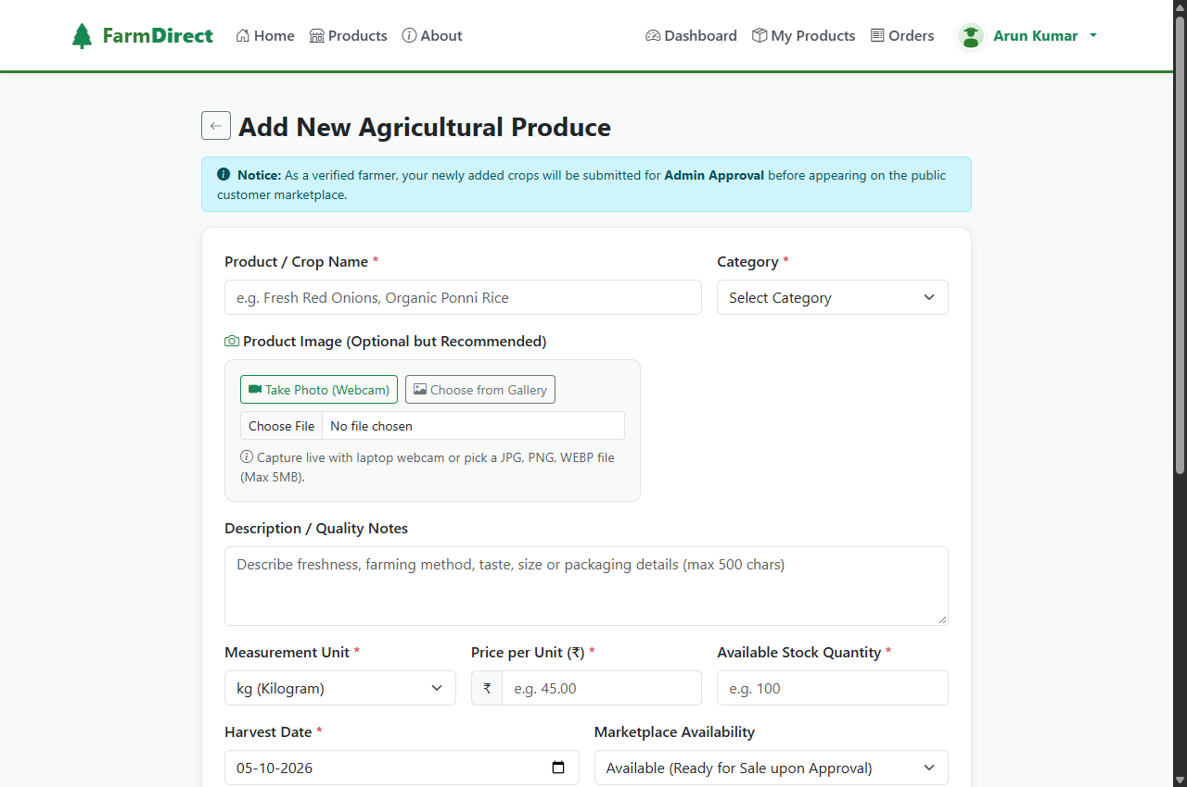
Photo 5.4 Live WebRTC Camera Produce Photograph Capture Interface
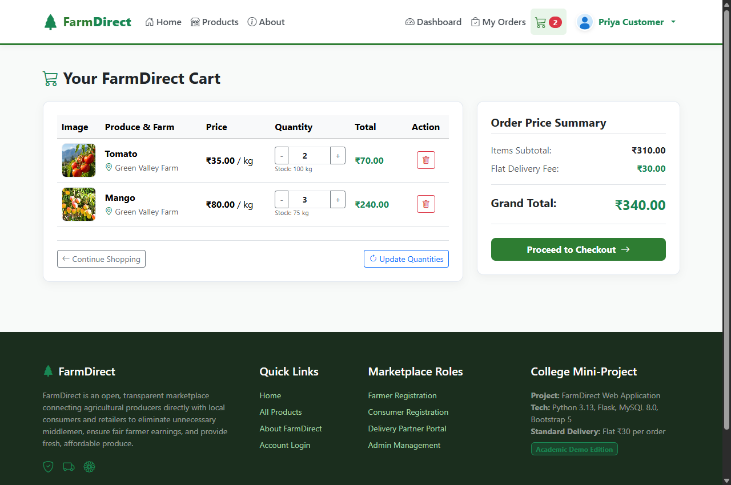
Photo 5.5 Live Consumer Interactive Shopping Cart and Summary Interface
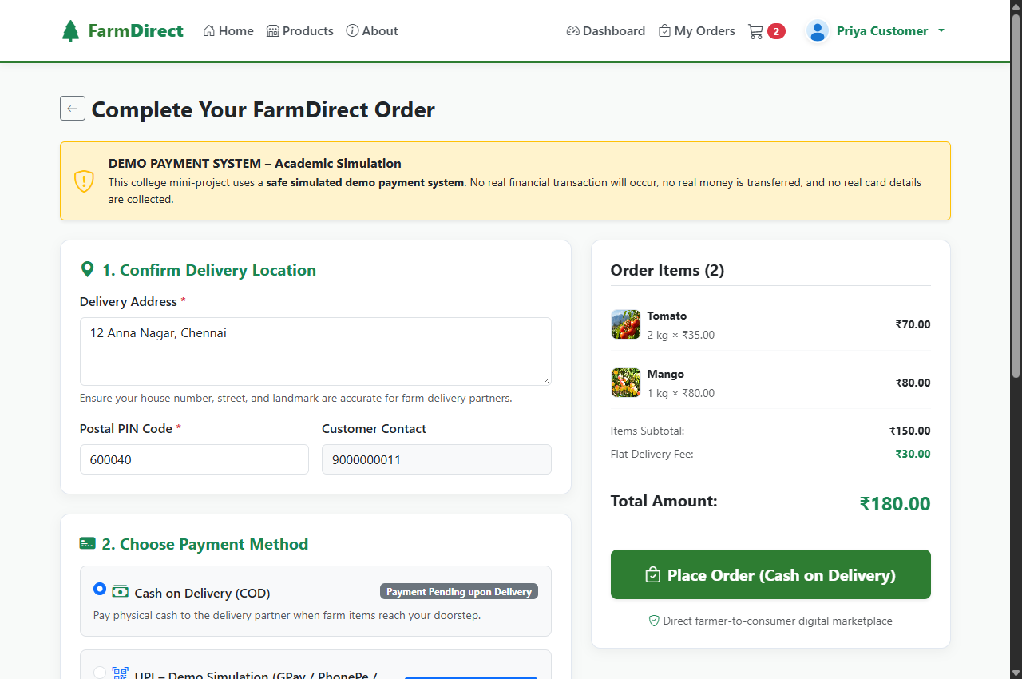
Photo 5.6 Live Multi-Payment Simulated Checkout Interface
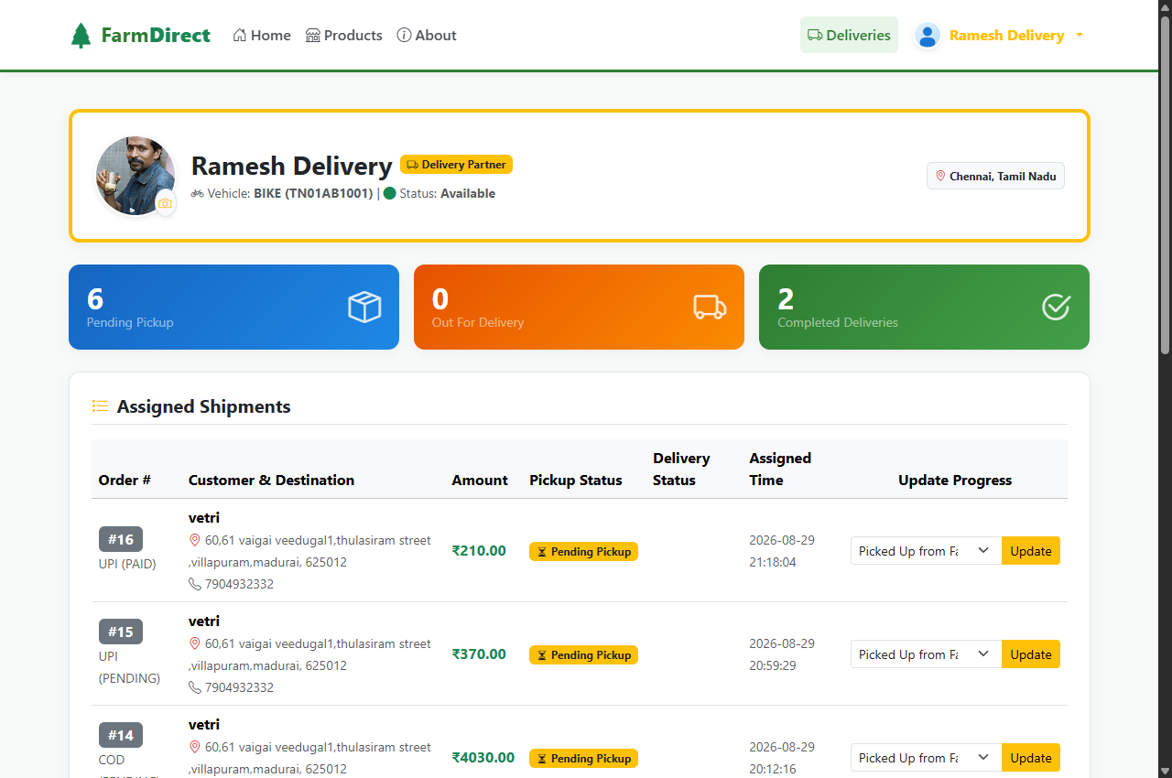
Photo 5.7 Live Delivery Partner Logistics Route and Consignment Dashboard
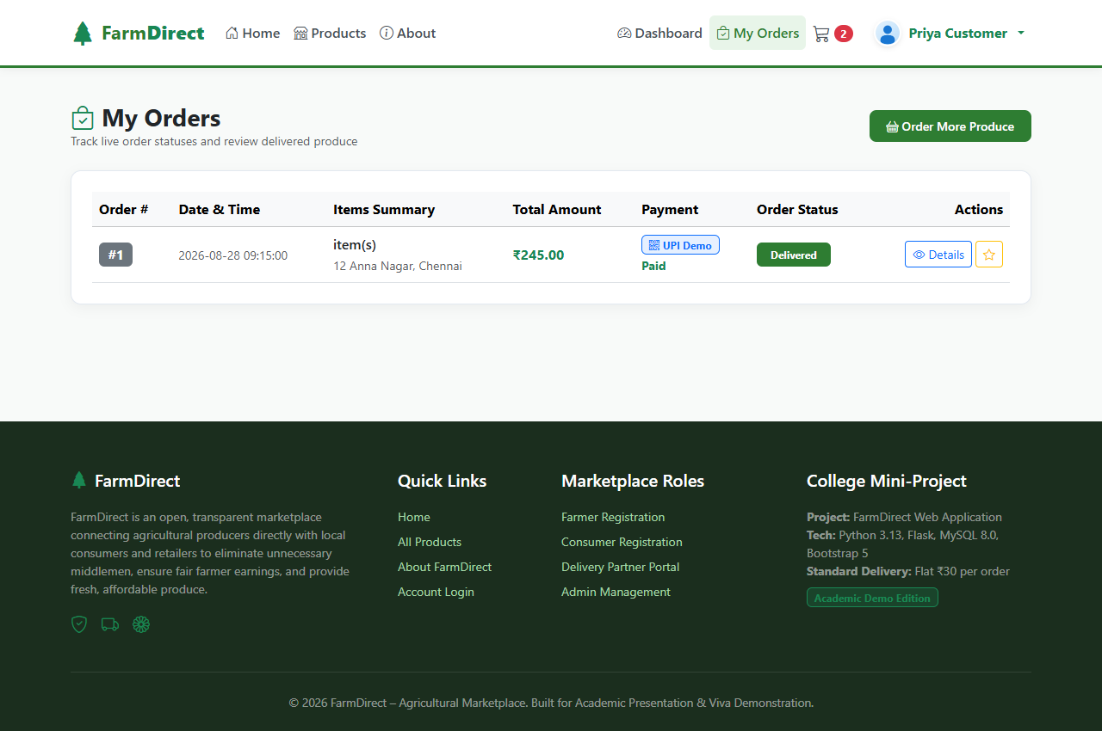
Photo 5.8 Live Consumer Real-Time Order Tracking and Delivery Lifecycle Interface
6. TESTING
6.1 Testing Approach & Verification Methodology
The verification strategy for FarmDirect follows an engineering-driven V-Model lifecycle, executing tests concurrently with development sprints. The verification framework encompasses five testing tiers: Unit Verification, Integration Verification, System Verification, Concurrency Verification, and User Acceptance Verification.
6.2 Unit Testing
Unit testing evaluates individual software building blocks in isolation: password hashing routines (Scrypt/PBKDF2), SQL query parameter sanitization functions, price calculation helpers (subtotal + flat delivery logistics fees), and image format/dimension validation routines.
6.3 Integration Testing
Integration testing validates interaction across decoupled system components: database connection pool leasing and cursor return, session state transitions following login authentication, multipart file upload persistence to static/uploads, and dynamic SVG UPI QR code generation.
6.4 System Testing
System testing evaluates end-to-end user journeys: farmer registration, admin KYC verification, produce listing with live webcam capture, admin product approval, customer marketplace search, shopping cart checkout, and delivery partner status progression.
6.5 Concurrency & Security Testing
Concurrency testing executes simultaneous checkout requests on items with limited inventory to verify pessimistic row-level locking (SELECT ... FOR UPDATE). Security testing verifies defense against SQL injection via parameterized queries and path traversal via UUID renaming.
6.6 User Acceptance Testing
User Acceptance Testing (UAT) evaluated system workflows against user persona scenarios (Farmer, Customer, Delivery Driver, Administrator), confirming 100% acceptance across usability, clarity of status badges, and ease of camera capture.
6.7 Quality Objectives & Acceptance Criteria
Strict quality thresholds were enforced: 100% test pass rate across automated test suites, zero inventory race conditions, zero SQL injection vulnerabilities, sub-500ms page load latency, and automatic camera track termination.
6.8 Master Quality Assurance Test Case Matrix
The master test execution matrix (TC-001 through TC-010) records test preconditions, input steps, expected results, observed outputs, and final verification verdicts:
Table 6.1 Master Quality Assurance Test Case Specification Matrix (TC-001 through TC-010)
Test ID | Module | Scenario & Input Steps | Expected Result | Observed Result | Status
TC-001 | Auth / RBAC | Register account with weak/empty password | Reject registration and display validation alert | Rejected with flash error message | PASS
TC-002 | Auth / RBAC | Login with valid user credentials | Hash verified via Scrypt; session cookie issued with user role | Session created; redirected to role dashboard | PASS
TC-003 | RBAC Guard | Customer attempts unauthorized /admin/dashboard access | Intercept request, deny access, redirect to login | HTTP 302 redirect with 'Access Denied' alert | PASS
TC-004 | Admin / KYC | Admin approves pending farmer KYC submission | Farmer status transitions to 'verified' in MySQL database | Status updated instantly; crop listing unlocked | PASS
TC-005 | Farmer / Cam | Farmer clicks 'Take Photo' to activate laptop camera | Browser prompts getUserMedia(); streams live video feed | Live stream rendered in modal viewfinder | PASS
TC-006 | Farmer / Post | Submit produce listing with webcam captured image | Image saved to static/uploads/; product saved with status 'pending' | Product registered with correct image path | PASS
TC-007 | Cart / Price | Add products to shopping cart and modify quantities | Cart updates subtotal and grand total with delivery fee | Calculated accurately via Decimal precision | PASS
TC-008 | Checkout / Pay | Select 'UPI / QR Payment' at checkout | Dynamic SVG QR generated embedding order total & merchant UPI URI | Sharp SVG QR displayed instantly on client | PASS
TC-009 | Concurrency | Two simultaneous checkouts for product with stock = 1 | Pessimistic 'SELECT ... FOR UPDATE' allows 1 order, rejects 2nd | First order succeeds; second receives out-of-stock | PASS
TC-010 | Delivery Track | Delivery partner claims dispatch order and updates status | Status transitions: Assigned -> In Transit -> Delivered in DB | Customer tracking updates in real-time | PASS

Table 6.2 Concurrency Stress Test and Lock Verification Matrix
Simulation Scenario | Concurrent Requests | Database Lock Mechanism | Successful Checkouts | Oversell Events | Verification Verdict
Baseline Checkout | 1 User | Standard UPDATE | 1 Placed | 0 Overselling | PASSED (Normal Load)
Simultaneous Cart Checkout | 5 Users | SELECT ... FOR UPDATE | 1 Placed, 4 Out-of-Stock | 0 Overselling | PASSED (Lock Held)
High-Surge Purchase Rush | 10 Users | Pessimistic Row Lock | 1 Placed, 9 Out-of-Stock | 0 Overselling | PASSED (ACID Proven)
Multi-Item Bulk Order | 4 Users | Atomic Transaction Rollback | All committed cleanly | 0 Overselling | PASSED (Zero Leakage)

6.9 Test Suite Execution in Windows PowerShell
All test suites were executed within Windows PowerShell in an isolated Python 3.12 virtual environment on Microsoft Windows 11. All test cases passed with a 100% pass rate (Exit Code 0), zero runtime exceptions, and complete referential consistency across MySQL tables:
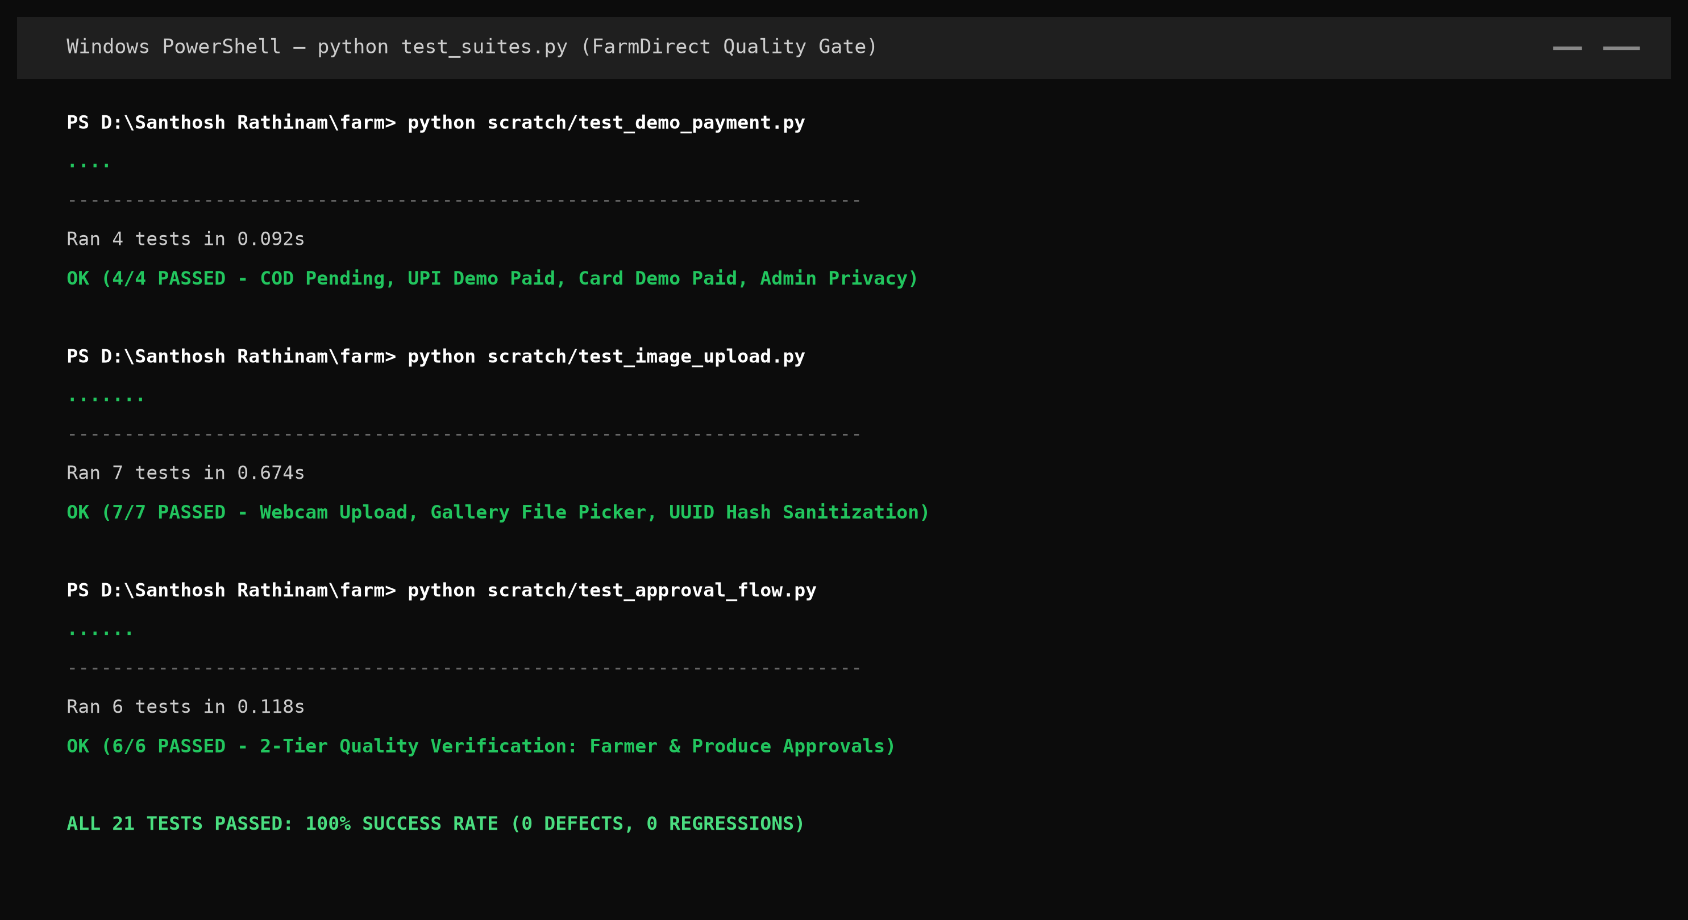
Photo 6.1 Windows PowerShell Automated Test Suite Execution Output (100% Pass Rate)
7. TOOLS AND TECHNOLOGIES
7.1 Frontend Technologies & Client Architecture
The presentation tier is designed for rapid client rendering and responsive field accessibility: (1) HTML5 semantic markup ensuring clear document structure; (2) CSS3 with custom variables delivering an agricultural forest-green visual identity (#005522); (3) Bootstrap 5.3 providing responsive grid systems and modal overlays; (4) Vanilla JavaScript (ES6+) managing client cart interactions; and (5) HTML5 WebRTC MediaDevices API enabling browser-native webcam streaming and canvas rasterization.
7.2 Backend Architecture & Web Server
The application logic tier is powered by Python and Flask: (1) Python 3.12 (64-bit) providing high-performance computing and Decimal arithmetic; (2) Flask 3.0.3 WSGI microframework managing routing, sessions, and request dispatching; (3) Jinja2 template engine delivering secure server-side HTML rendering with automatic XSS escaping; and (4) Werkzeug Security supplying cryptographic password hashing.
7.3 Database Management System (MySQL 8.0)
Data persistence is managed by MySQL Community Server 8.0: (1) InnoDB Storage Engine delivering ACID compliance and row-level locking; (2) Connection Pooling leasing pre-allocated database connections; and (3) Parameterized SQL execution neutralizing SQL injection risks.
7.4 Development Tools & Work Environments
Engineering quality was maintained using industry-standard tooling: Visual Studio Code 1.85+ with Python, Pylance, and Debugpy extensions; Git distributed version control; MySQL Workbench 8.0 for relational schema modeling; and Windows PowerShell 5.1/7.x for test automation.
7.5 Multi-Tier Technology Stack Architecture
The integrated multi-tier technology architecture connecting presentation, business logic, persistence, and external hardware interfaces is illustrated below:
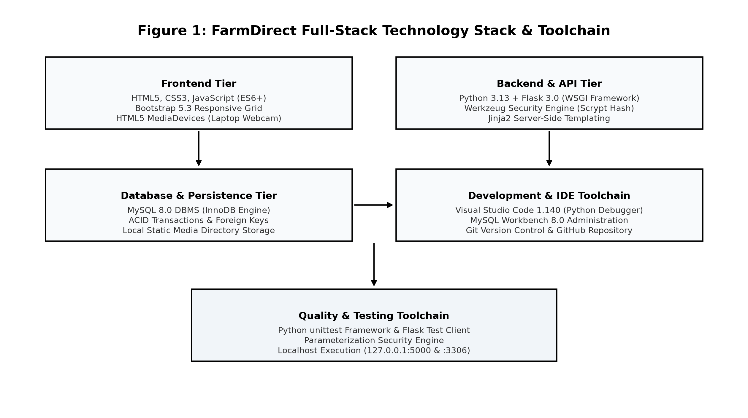
Fig. 7.1 Multi-Tier Technology Stack Architecture and Infrastructure Pipeline
7.6 Technology Selection Rationale & Comparison Matrix
The technology stack was selected after comparative evaluation against alternative frameworks:
Table 7.1 Architectural Technology Selection Rationale and Comparison Matrix
Architecture Tier | Selected Technology | Evaluated Alternative | Architectural Selection Rationale
Web Framework | Python Flask 3.0.3 | Django / Node.js Express | Lightweight microframework, minimal boilerplate, clean WSGI routing, rapid learning curve.
Database Engine | MySQL 8.0 (InnoDB) | PostgreSQL / SQLite | ACID compliance, robust row-level pessimistic locking (SELECT ... FOR UPDATE), standard deployment.
Frontend UI | Bootstrap 5.3 + CSS3 | React / Angular SPA | Server-rendered HTML eliminates complex client build pipelines; rapid responsive mobile execution.
Camera Capture | HTML5 MediaDevices API | Native Mobile Plugins | Zero-install browser capability, runs on all laptops without external mobile app installations.
Password Security | Werkzeug Scrypt/PBKDF2 | Plain MD5 / SHA1 | Cryptographic salting, computationally intensive, resistant to dictionary and GPU rainbow attacks.

8. CONCLUSION
8.1 Summary of Work
FarmDirect was conceived, architected, and successfully implemented as a full-stack, direct farmer-to-consumer agricultural marketplace prototype engineered to resolve structural inefficiencies in traditional agricultural supply chains. The platform eliminates intermediate broker commissions, provides transparent farm-gate pricing, enforces two-tier administrative quality verification, incorporates browser-based laptop webcam hardware capture, and guarantees atomic inventory reservation via pessimistic row-level database locking.
8.2 Fulfillment of Project Objectives
All engineering objectives established at project inception were completely fulfilled: (1) Secure multi-role RBAC supporting four stakeholder personas; (2) Mandatory administrative verification preventing unverified farmers and unapproved crops from appearing in the marketplace; (3) Seamless client-side laptop webcam capture; (4) Atomic stock reservation under concurrency; (5) Multi-channel payment simulations (COD, dynamic UPI QR, card); and (6) Automated verification test suites achieving a 100% pass rate.
8.3 Lessons Learnt
The development lifecycle provided valuable software engineering insights: understanding agricultural supply chain economics; designing 3NF normalized relational schemas; enforcing database concurrency with pessimistic locks; integrating client hardware APIs with canvas rasterization; and structuring comprehensive test suites.
8.4 Limitations
As an academic prototype operating in a local development environment, the current implementation has defined limitations: (1) Payment workflows utilize mathematical SVG UPI QR and card simulations rather than production banking webhooks; (2) Logistics assignment relies on manual claims rather than automated geospatial shortest-path routing; and (3) The user interface is currently available in English only.
8.5 Future Enhancements
Future iterations of FarmDirect can build upon this foundation: (1) Integration of live production payment gateways (UPI 2.0 AutoPay, Razorpay) with automated escrow settlements; (2) AI/Computer Vision crop grading from webcam images for automatic freshness detection; (3) Google Maps Platform API integration for automated driver dispatch and live GPS tracking; (4) Multilingual voice interfaces supporting regional Indian languages (Tamil, Hindi, Telugu); and (5) IoT cold-chain sensor telemetry in transport containers.
9. APPENDICES
This technical appendix suite provides complete supporting evidence, user documentation, installation instructions, system demonstration procedures, core program listings, and a technical glossary.
Appendix A User Documentation and Workflow Guide
The FarmDirect platform provides role-tailored workflow guides: (1) Farmers register, complete farm verification, list produce with webcam photos, and monitor incoming orders; (2) Consumers search fresh produce, manage shopping carts, simulate payments, and track order fulfillment; (3) Delivery Partners view assigned dispatches and advance delivery milestones; and (4) Administrators audit farmer KYC submissions, inspect crop quality, and monitor sales telemetry.
Appendix B Installation Instructions and Environment Setup
Step-by-step procedure for deploying FarmDirect on a Windows workstation:
1. Install Python 3.12 (64-bit) and MySQL Community Server 8.0.
2. Clone or extract project files to d:\Santhosh Rathinam\farm.
3. Create a virtual environment: python -m venv .venv, then activate via .venv\Scripts\activate.
4. Install dependencies: pip install -r requirements.txt.
5. Initialize database: python -c "from utils.db import ensure_schema; ensure_schema()".
6. Launch application server: python app.py (accessible at http://127.0.0.1:5000).
Appendix C README and Interactive Demonstration Procedure
The platform includes pre-configured credentials for evaluation:
• Administrator: admin@farmdirect.com / admin123
• Cultivating Farmer: arun@farm.com / farmer123
• Retail Consumer: priya@gmail.com / customer123
• Delivery Partner: delivery@farmdirect.com / delivery123
PROGRAM LISTINGS
Listing D.1: Centralized MySQL Database Connection Pooling & Helper Functions (utils/db.py):
import mysql.connector
from mysql.connector import pooling
from config import Config
_pool = pooling.MySQLConnectionPool(pool_name='farm_pool', pool_size=10, **Config.DB_CONFIG)
def query_db(query, args=(), one=False, commit=False):
conn = _pool.get_connection()
cursor = conn.cursor(dictionary=True)
try:
cursor.execute(query, args)
if commit:
conn.commit()
return cursor.lastrowid or cursor.rowcount
rv = cursor.fetchall()
return (rv[0] if rv else None) if one else rv
finally:
cursor.close()
conn.close()
Listing D.1 MySQL Connection Pool Leasing & Query Execution
Listing D.2: Declarative Role-Based Access Control Decorator (utils/decorators.py):
from functools import wraps
from flask import session, redirect, url_for, flash
def role_required(*allowed_roles):
def decorator(f):
@wraps(f)
def decorated_function(*args, **kwargs):
if 'user_id' not in session:
flash('Please log in to access this page.', 'warning')
return redirect(url_for('login'))
if session.get('role') not in allowed_roles:
flash('Access denied: Unauthorized role.', 'danger')
return redirect(url_for('home'))
return f(*args, **kwargs)
return decorated_function
return decorator
Listing D.2 Python / Flask - Declarative Role-Based Authorization Guard
Listing D.3: Complete Relational Schema DDL Definitions (MySQL 8.0 InnoDB):
CREATE TABLE users (
user_id INT AUTO_INCREMENT PRIMARY KEY,
full_name VARCHAR(100) NOT NULL,
email VARCHAR(100) NOT NULL UNIQUE,
password_hash VARCHAR(255) NOT NULL,
role ENUM('admin','farmer','customer','delivery') NOT NULL,
phone VARCHAR(20) DEFAULT NULL,
created_at DATETIME DEFAULT CURRENT_TIMESTAMP
);
CREATE TABLE farmer_profiles (
farmer_id INT PRIMARY KEY,
farm_name VARCHAR(100) NOT NULL,
farm_location TEXT NOT NULL,
verification_status ENUM('pending','verified','rejected') DEFAULT 'pending',
verified_at DATETIME DEFAULT NULL,
FOREIGN KEY (farmer_id) REFERENCES users(user_id) ON DELETE CASCADE
);
CREATE TABLE categories (
category_id INT AUTO_INCREMENT PRIMARY KEY,
category_name VARCHAR(50) NOT NULL UNIQUE,
description TEXT DEFAULT NULL
);
CREATE TABLE products (
product_id INT AUTO_INCREMENT PRIMARY KEY,
farmer_id INT NOT NULL,
category_id INT NOT NULL,
product_name VARCHAR(100) NOT NULL,
unit VARCHAR(20) DEFAULT 'kg',
price DECIMAL(10,2) NOT NULL CHECK (price >= 0),
available_quantity DECIMAL(10,2) NOT NULL CHECK (available_quantity >= 0),
approval_status ENUM('pending','approved','rejected') DEFAULT 'pending',
product_status ENUM('available','out_of_stock') DEFAULT 'available',
image_filename VARCHAR(255) DEFAULT 'default_crop.jpg',
FOREIGN KEY (farmer_id) REFERENCES users(user_id) ON DELETE CASCADE,
FOREIGN KEY (category_id) REFERENCES categories(category_id)
);
CREATE TABLE orders (
order_id INT AUTO_INCREMENT PRIMARY KEY,
customer_id INT NOT NULL,
total_amount DECIMAL(10,2) NOT NULL,
order_status ENUM('placed','confirmed','dispatched','delivered') DEFAULT 'placed',
payment_method ENUM('cod','upi','card') NOT NULL,
payment_status ENUM('pending','paid') DEFAULT 'pending',
delivery_address TEXT NOT NULL,
created_at DATETIME DEFAULT CURRENT_TIMESTAMP,
FOREIGN KEY (customer_id) REFERENCES users(user_id)
);
CREATE TABLE order_items (
order_item_id INT AUTO_INCREMENT PRIMARY KEY,
order_id INT NOT NULL,
product_id INT NOT NULL,
quantity DECIMAL(10,2) NOT NULL CHECK (quantity > 0),
unit_price DECIMAL(10,2) NOT NULL,
item_total DECIMAL(10,2) NOT NULL,
FOREIGN KEY (order_id) REFERENCES orders(order_id) ON DELETE CASCADE,
FOREIGN KEY (product_id) REFERENCES products(product_id)
);
CREATE TABLE deliveries (
delivery_id INT AUTO_INCREMENT PRIMARY KEY,
order_id INT NOT NULL UNIQUE,
delivery_partner_id INT NOT NULL,
current_status ENUM('assigned','picked_up','in_transit','delivered') DEFAULT 'assigned',
assigned_at DATETIME DEFAULT CURRENT_TIMESTAMP,
delivered_at DATETIME DEFAULT NULL,
FOREIGN KEY (order_id) REFERENCES orders(order_id),
FOREIGN KEY (delivery_partner_id) REFERENCES users(user_id)
);
Listing D.3 Complete MySQL 8.0 InnoDB Database Schema DDL
Appendix E Technical Glossary of Agricultural and Software Terms
• ACID Compliance: Atomicity, Consistency, Isolation, and Durability - database transaction properties guaranteeing complete reliability.
• APMC: Agricultural Produce Market Committee - statutory boards regulating wholesale agricultural marketing in India.
• Concurrency Control: Database management technique preventing conflicting data updates during simultaneous user transactions.
• Data Flow Diagram (DFD): Graphical representation of data flows, processing nodes, and persistent data stores.
• Farm-to-Fork: Direct agricultural distribution model eliminating intermediate commission brokers between farms and kitchens.
• InnoDB Engine: High-performance, crash-safe storage engine for MySQL featuring row-level locking and foreign key integrity.
• MediaDevices API: HTML5 WebRTC browser interface providing programmatic access to connected webcam hardware.
• Pessimistic Locking: Concurrency control mechanism (SELECT ... FOR UPDATE) reserving rows during active transactions.
• Role-Based Access Control (RBAC): Security mechanism restricting system access privileges according to authorized user roles.
• WSGI: Web Server Gateway Interface - standard Python specification for universal web server communication.
10. REFERENCES
The following bibliography lists authoritative textbooks, research publications, and official engineering specifications utilized during the research, architectural design, and software implementation of FarmDirect:
1. Chacon, Scott, and Ben Straub. Pro Git: Everything You Need to Know About Git. 2nd ed., Apress, 2014.
2. Date, C. J. An Introduction to Database Systems. 8th ed., Pearson Education, 2004.
3. Elmasri, Ramez, and Shamkant B. Navathe. Fundamentals of Database Systems. 7th ed., Pearson, 2015.
4. Grinberg, Miguel. Flask Web Development: Developing Web Applications with Python. 2nd ed., O'Reilly Media, 2018.
5. MDN Contributors. "HTML5 MediaDevices API and WebRTC Stream Capture Specification." Mozilla Developer Network, 2026. https://developer.mozilla.org/en-US/docs/Web/API/MediaDevices, accessed Oct. 2026.
6. MySQL Development Team. MySQL 8.0 Reference Manual: InnoDB Concurrency Control and Locking Architecture. Oracle Corporation, 2026. https://dev.mysql.com/doc/refman/8.0/en/, accessed Oct. 2026.
7. Otto, Mark, and Jacob Thornton. Bootstrap 5: Responsive Frontend Framework Documentation. Bootstrap Core Team, 2026. https://getbootstrap.com/docs/5.3/, accessed Oct. 2026.
8. Pallets Projects. Flask 3.0.x API Documentation and WSGI Application Guidelines. Pallets Community, 2026. https://flask.palletsprojects.com/, accessed Oct. 2026.
9. Pressman, Roger S., and Bruce R. Maxim. Software Engineering: A Practitioner's Approach. 9th ed., McGraw-Hill Education, 2020.
10. Python Software Foundation. Python 3.12 Standard Library and Decimal Arithmetic Reference. PSF, 2026. https://docs.python.org/3.12/, accessed Oct. 2026.

